/Right click on project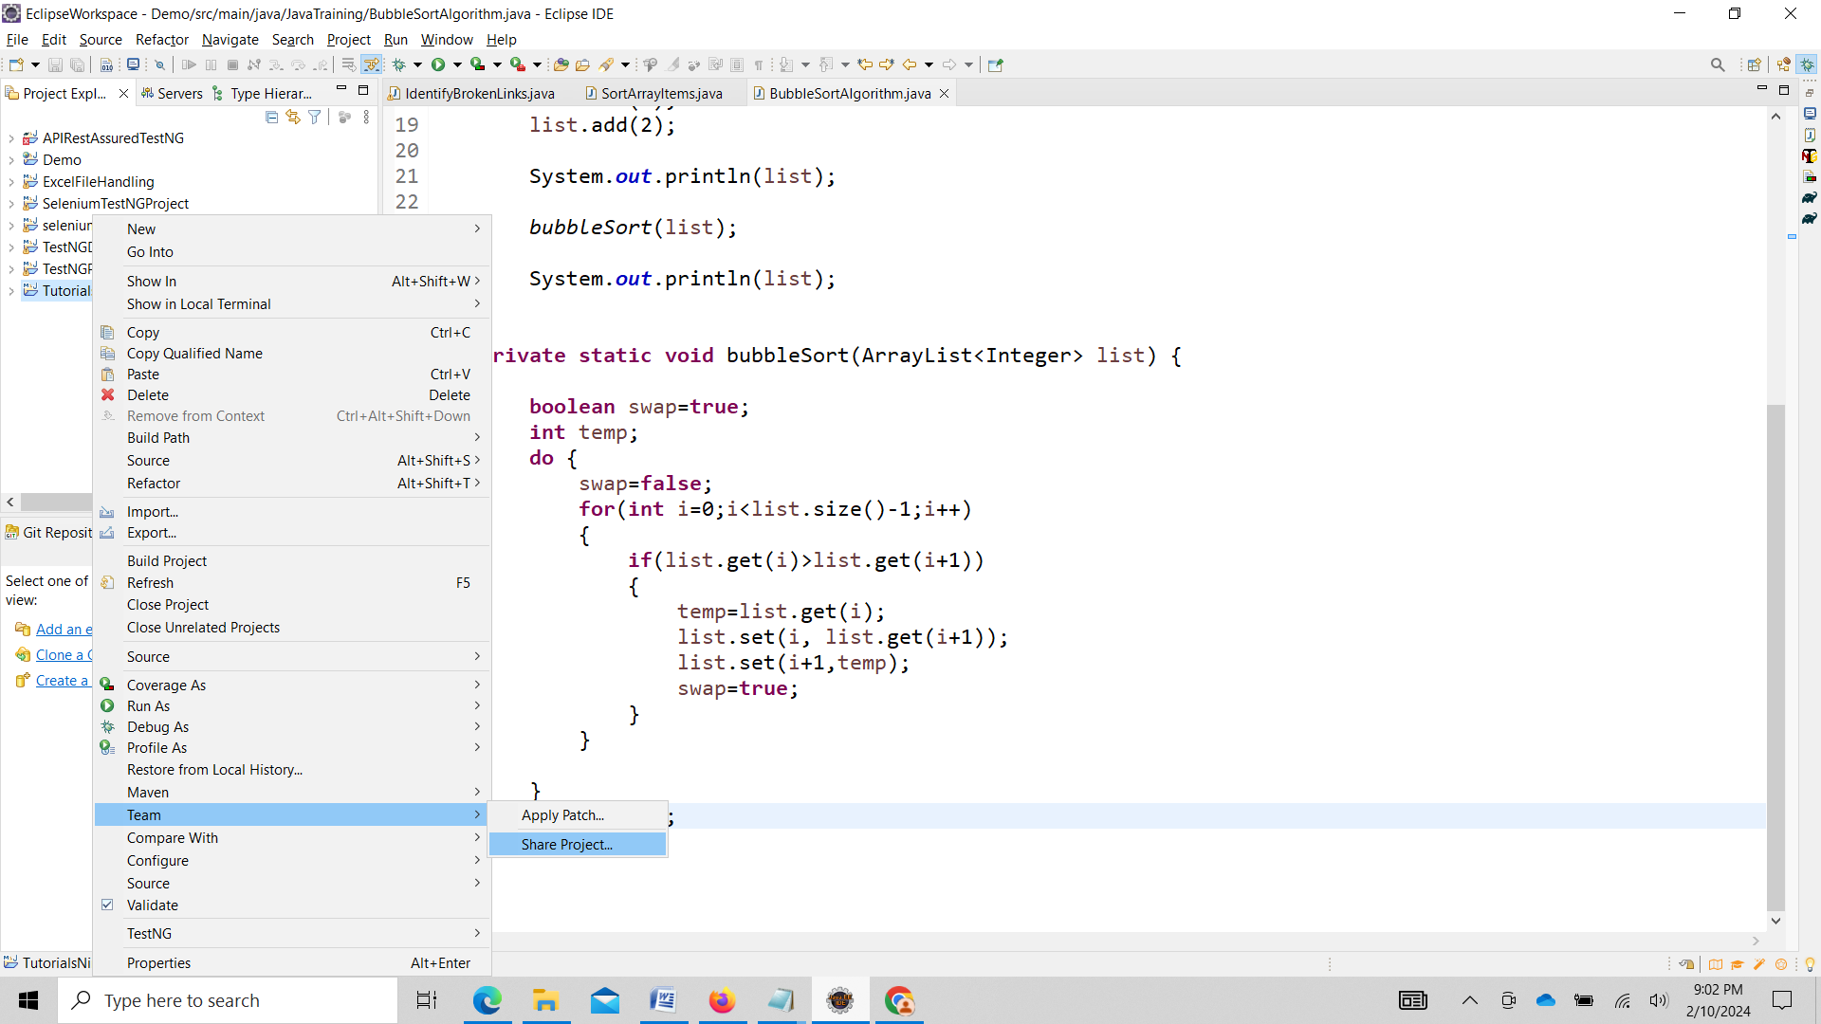

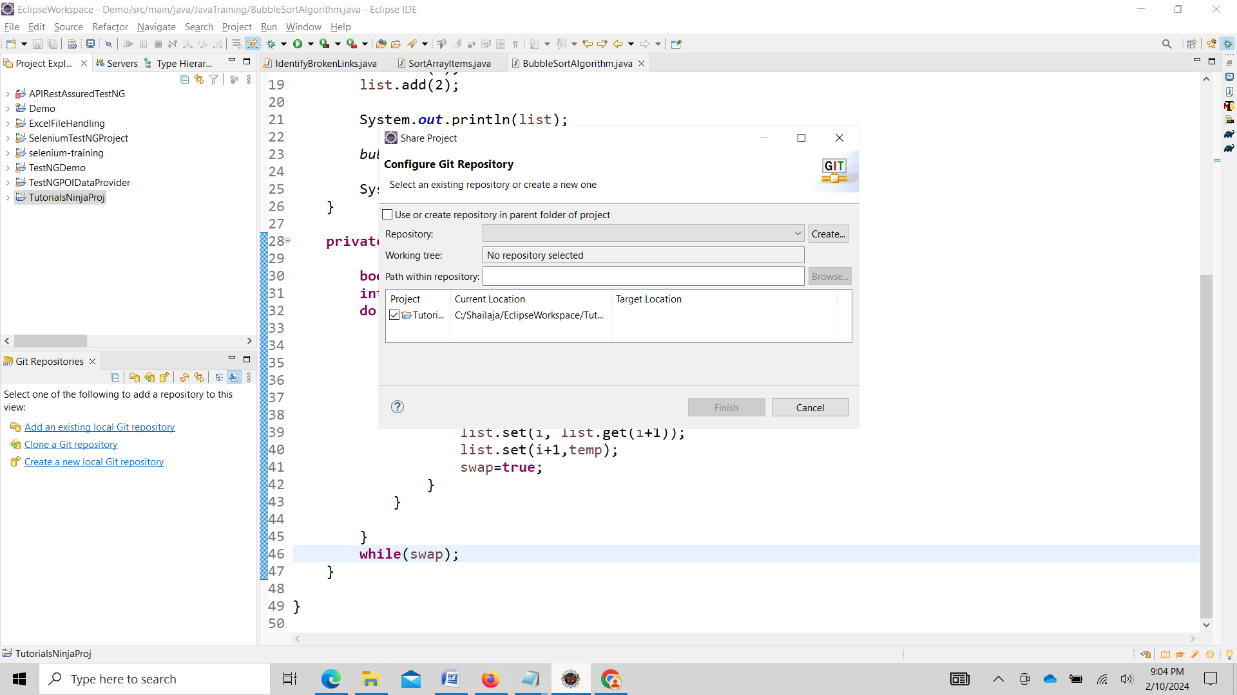

Select checkbox Use or create repository in parent folder of project

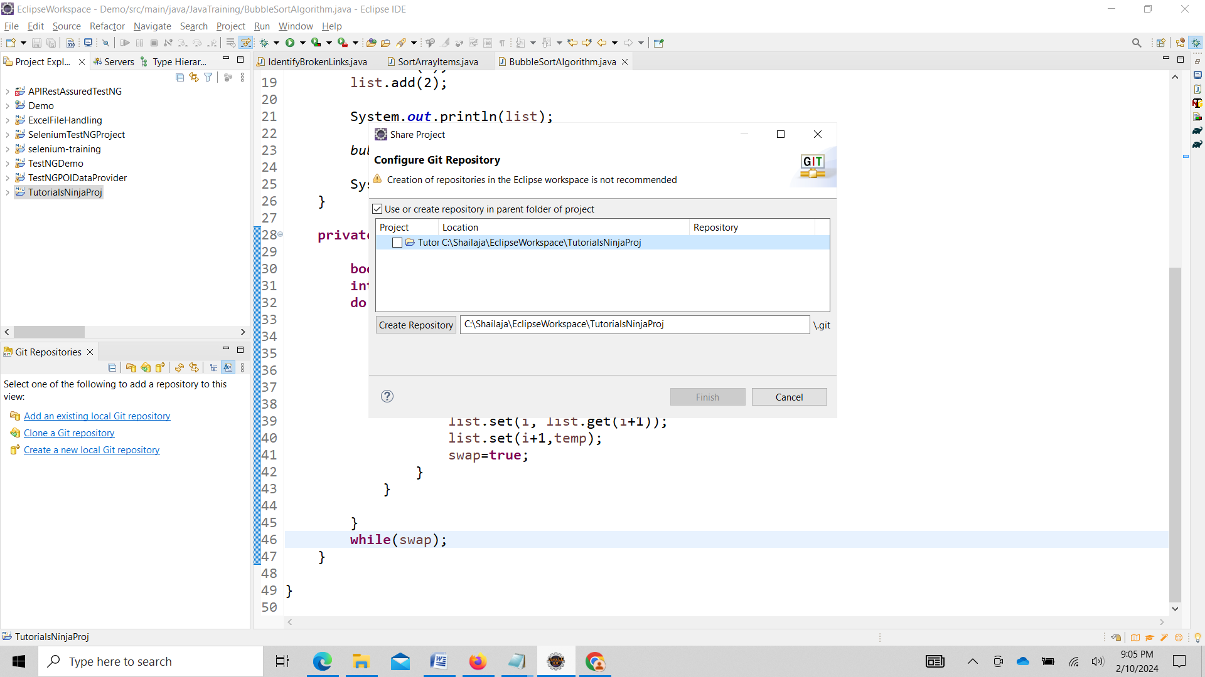

Click on create Repository

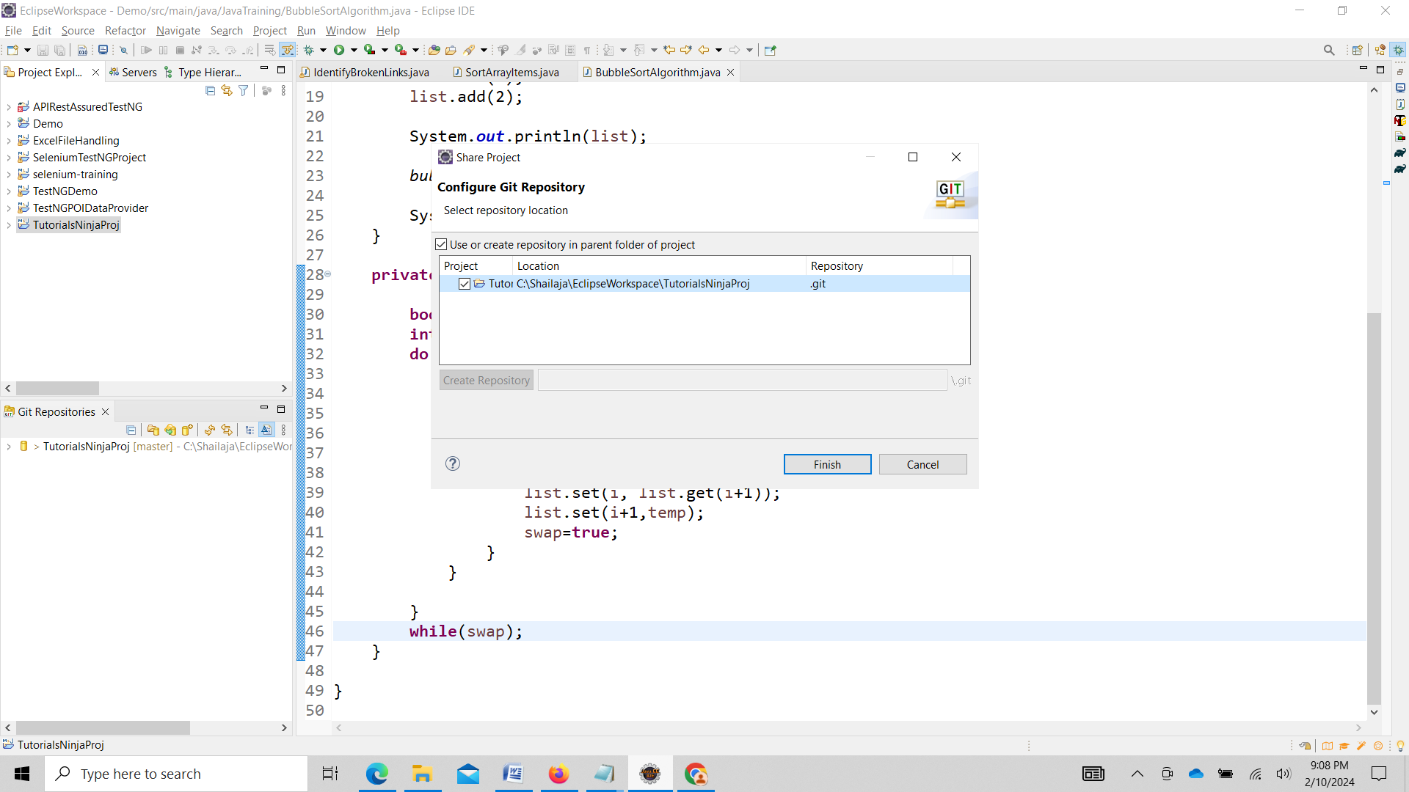

Click on finish



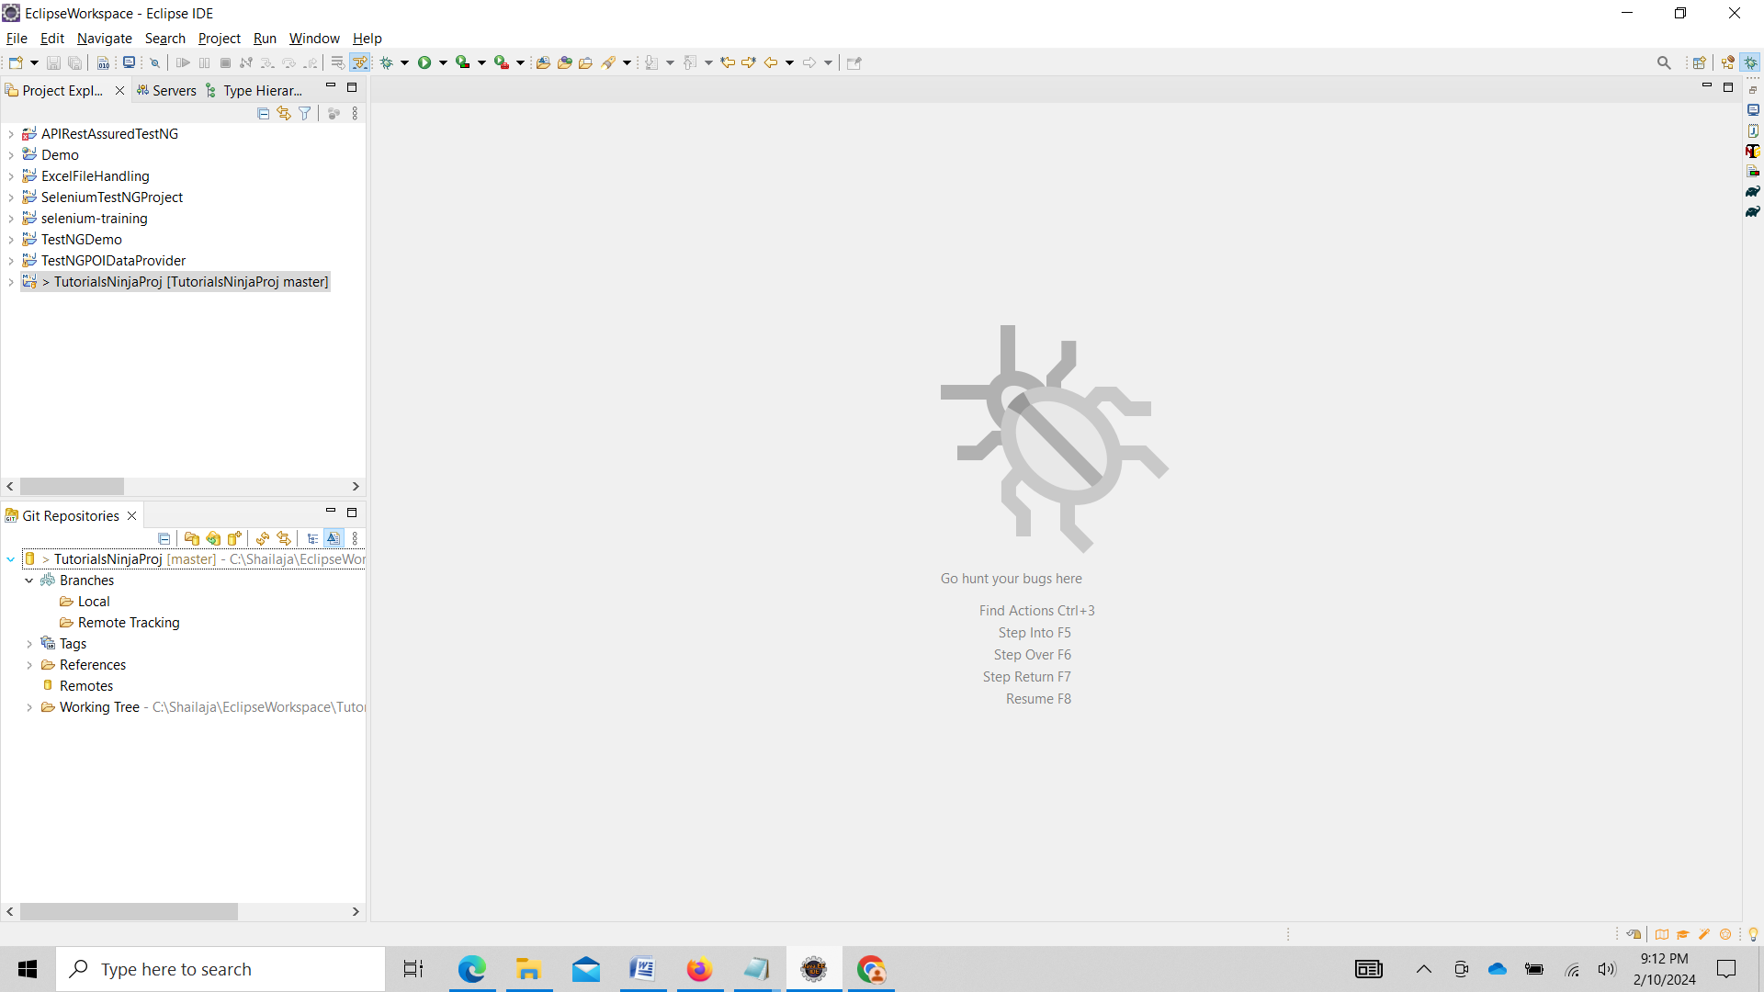

To Move project to staging area

Right click on project Select Team ->Add to Index

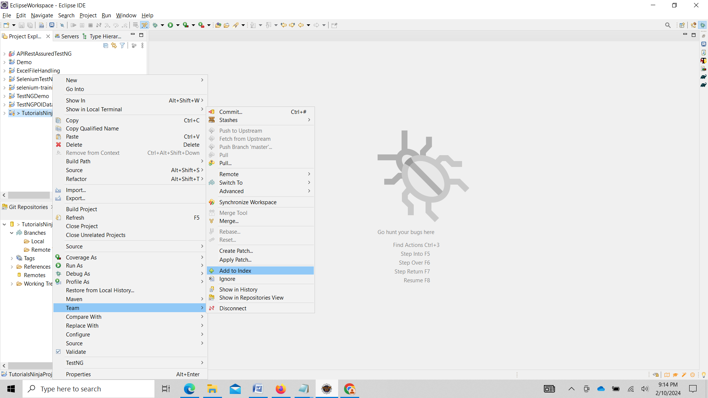

Commit to Local Repo

Right click on Project Select Team -> Commit

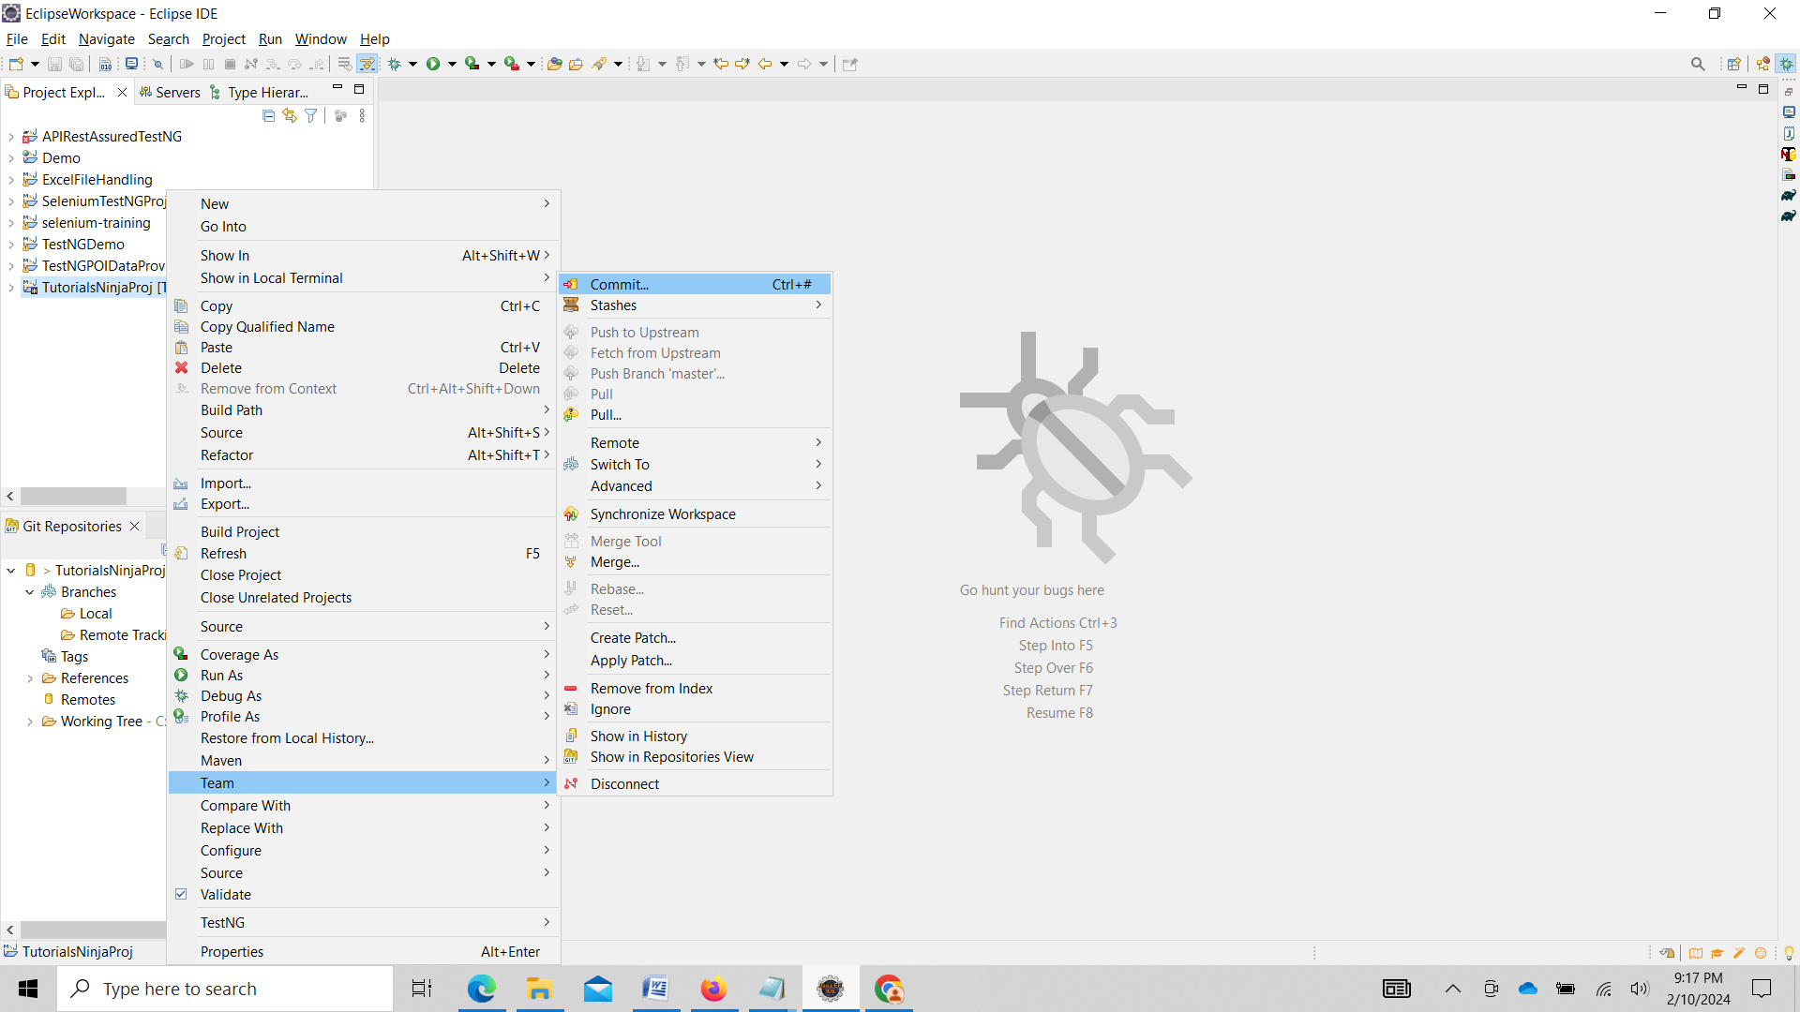

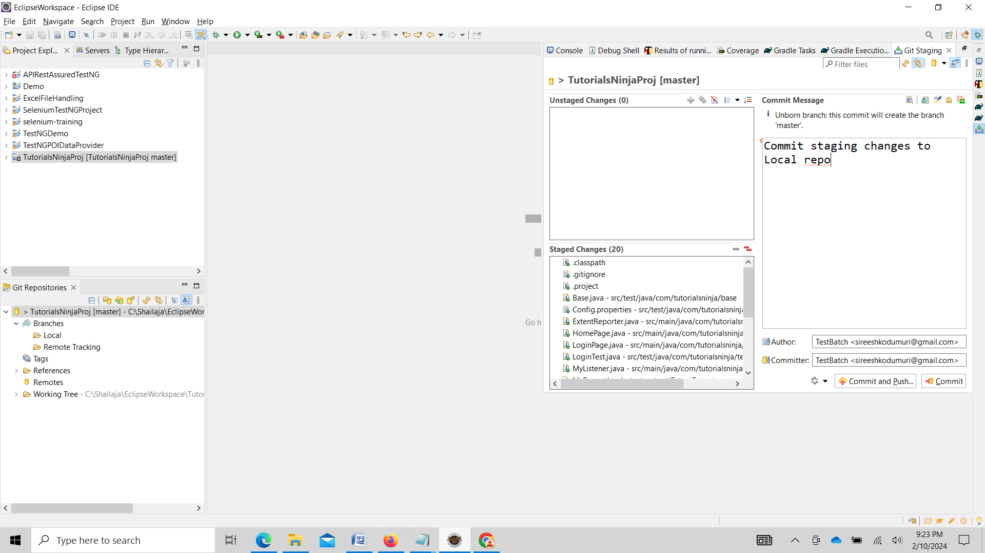

After commiting changes to local Repo under folder Local master appears

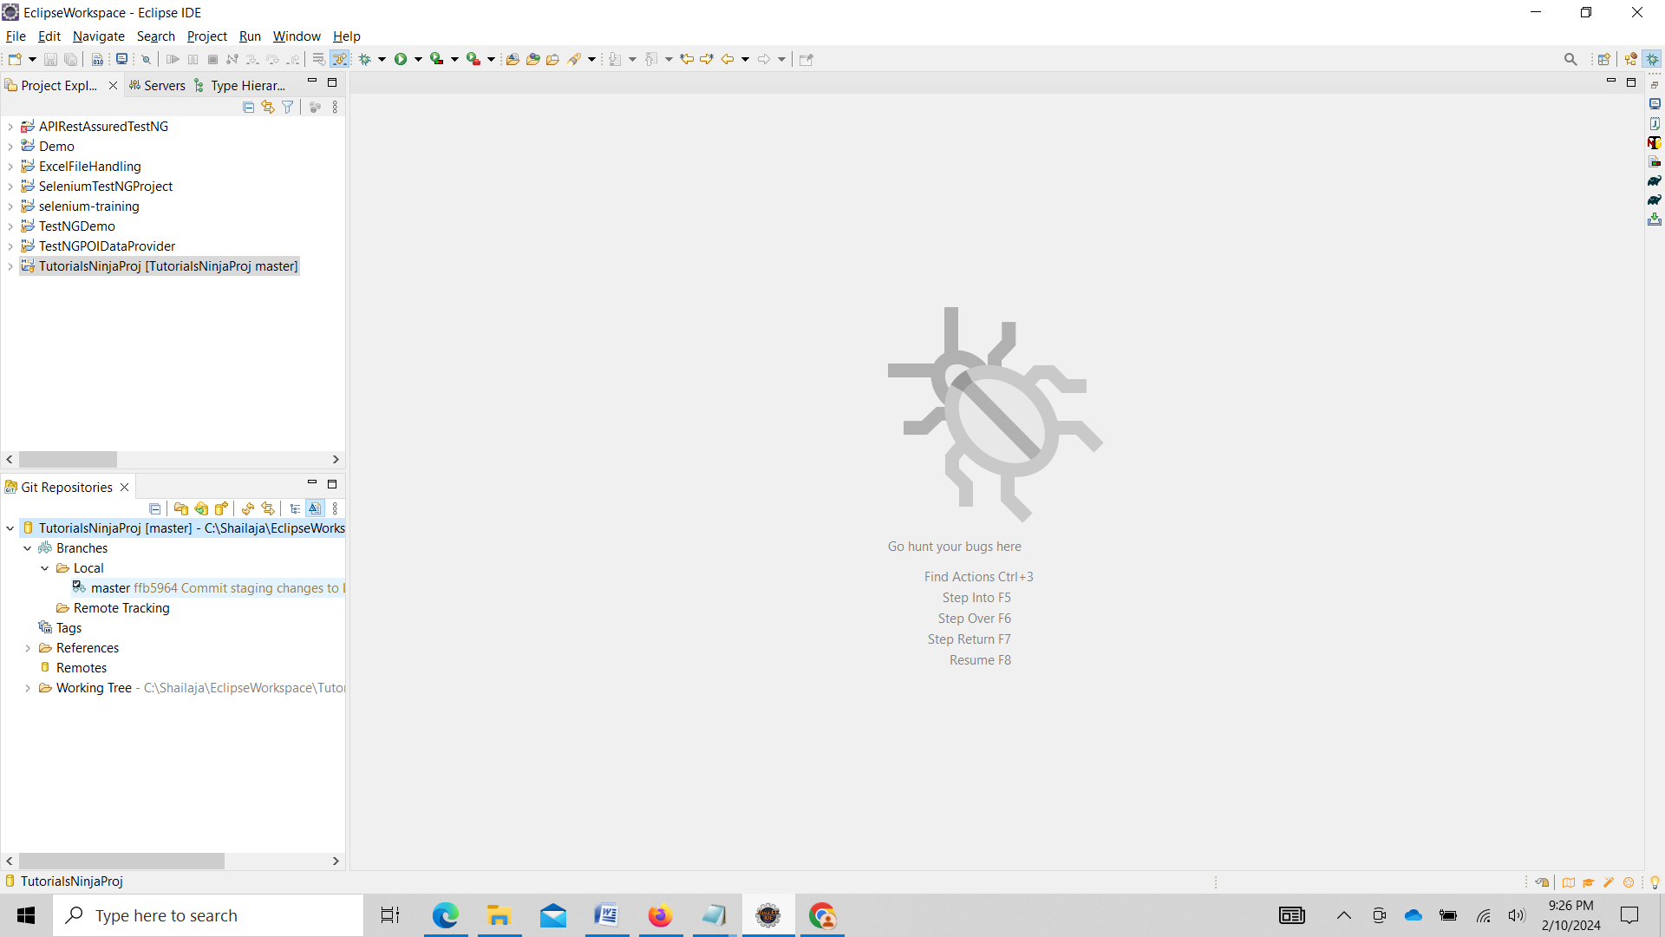

Creating Remote repository in Git Hub

Open

Open URL <https://github.com/> and click SignUp

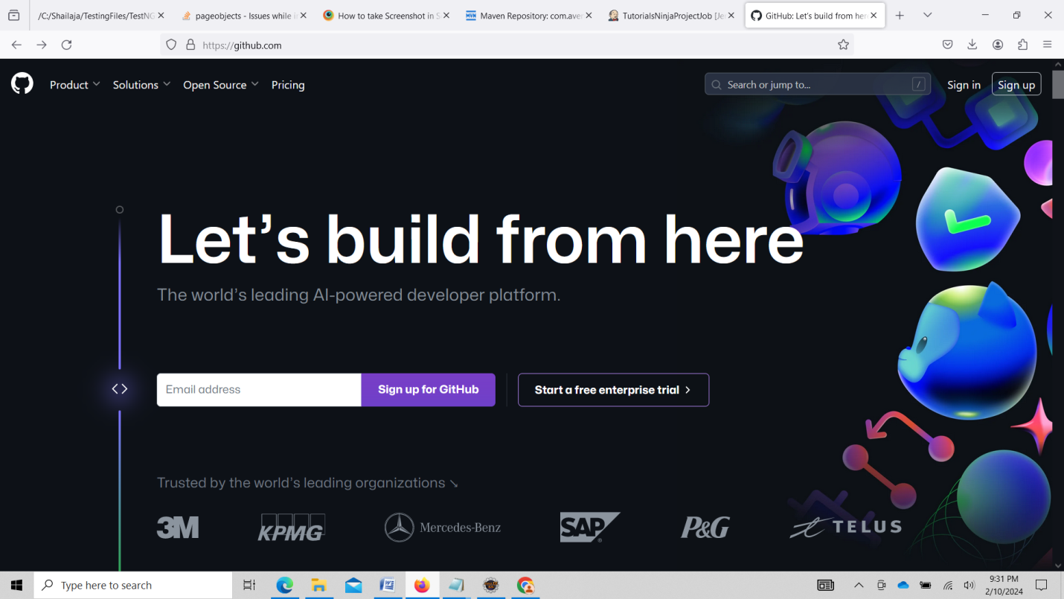

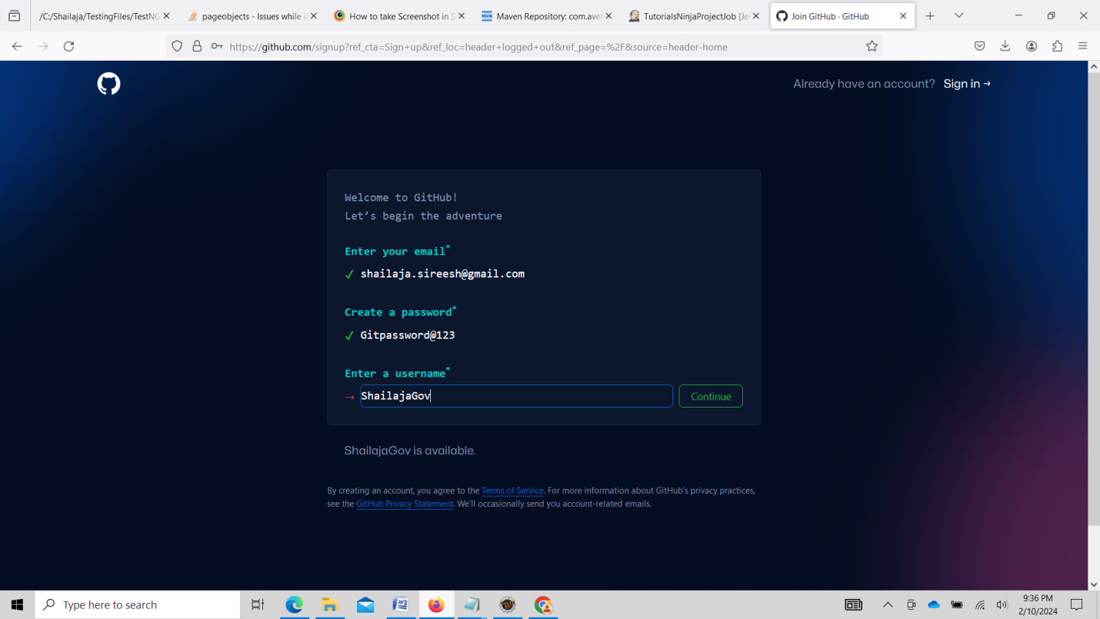

Gitpassword@123

GitHub dashboard

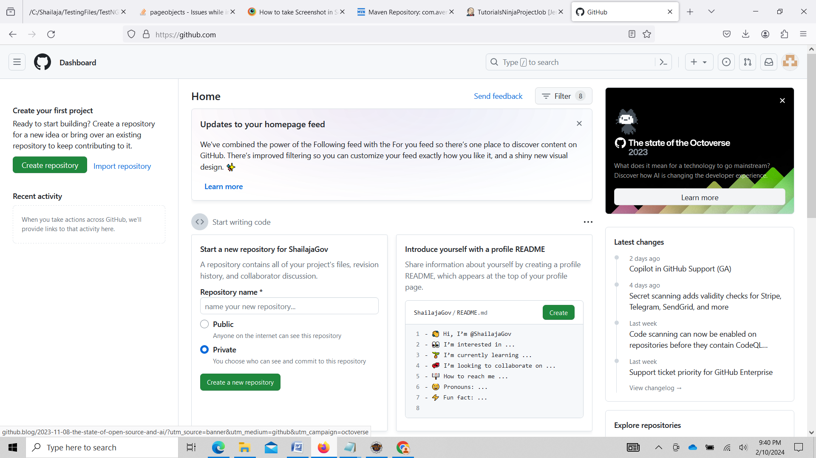

Select your repositories

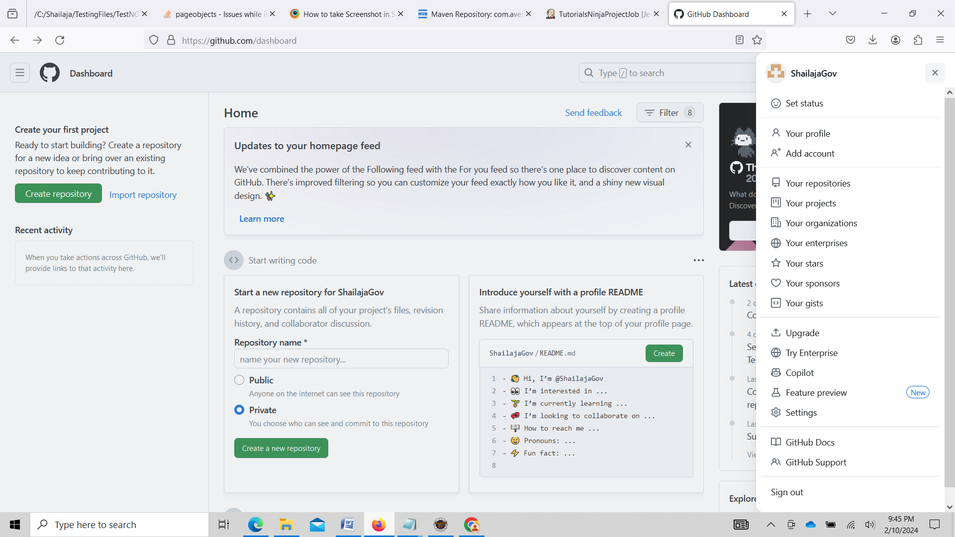

Click on New

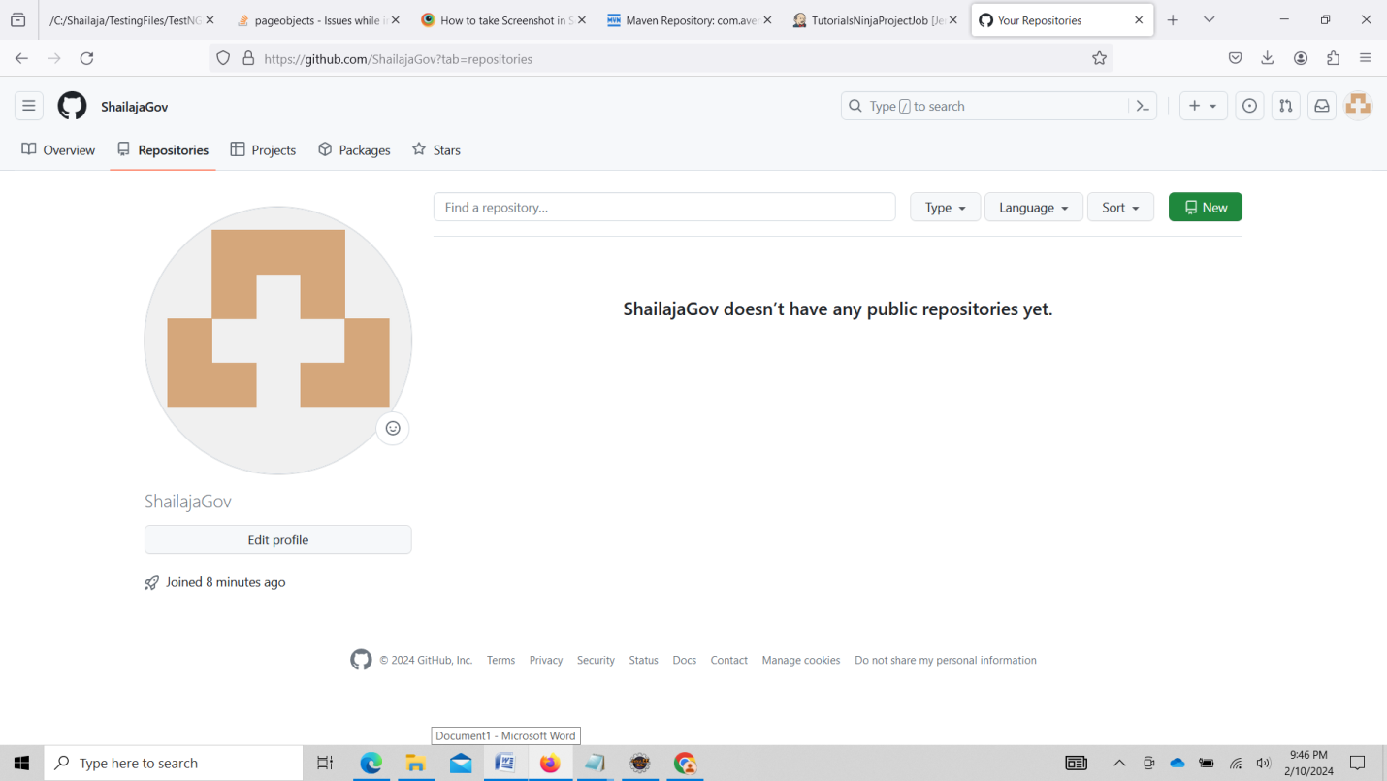

Click on create Repository

Select Public for learning in Real time project it should be private

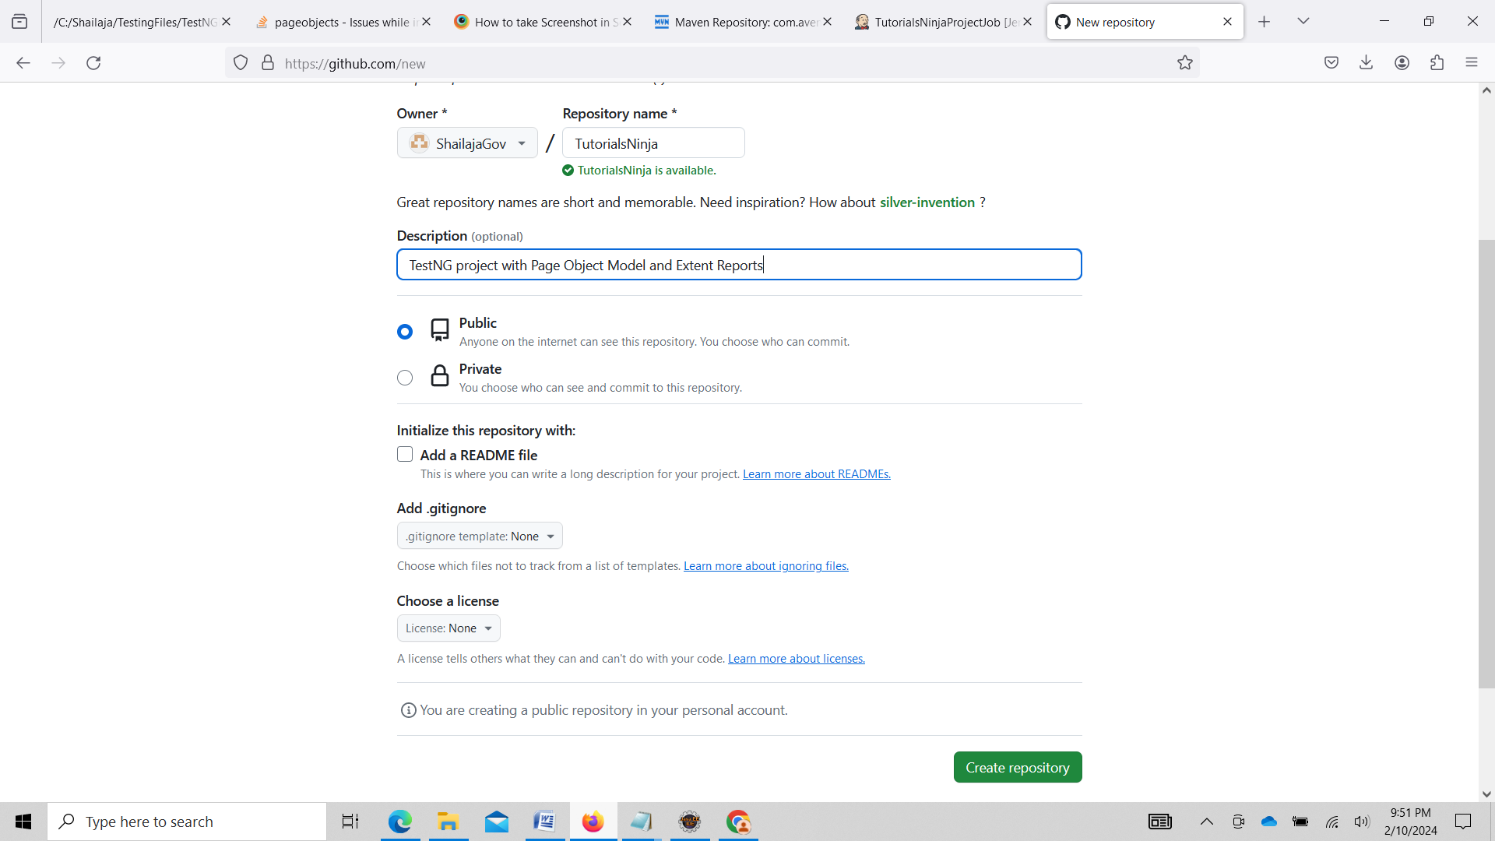

https://github.com/ShailajaGov/TutorialsNinja.git

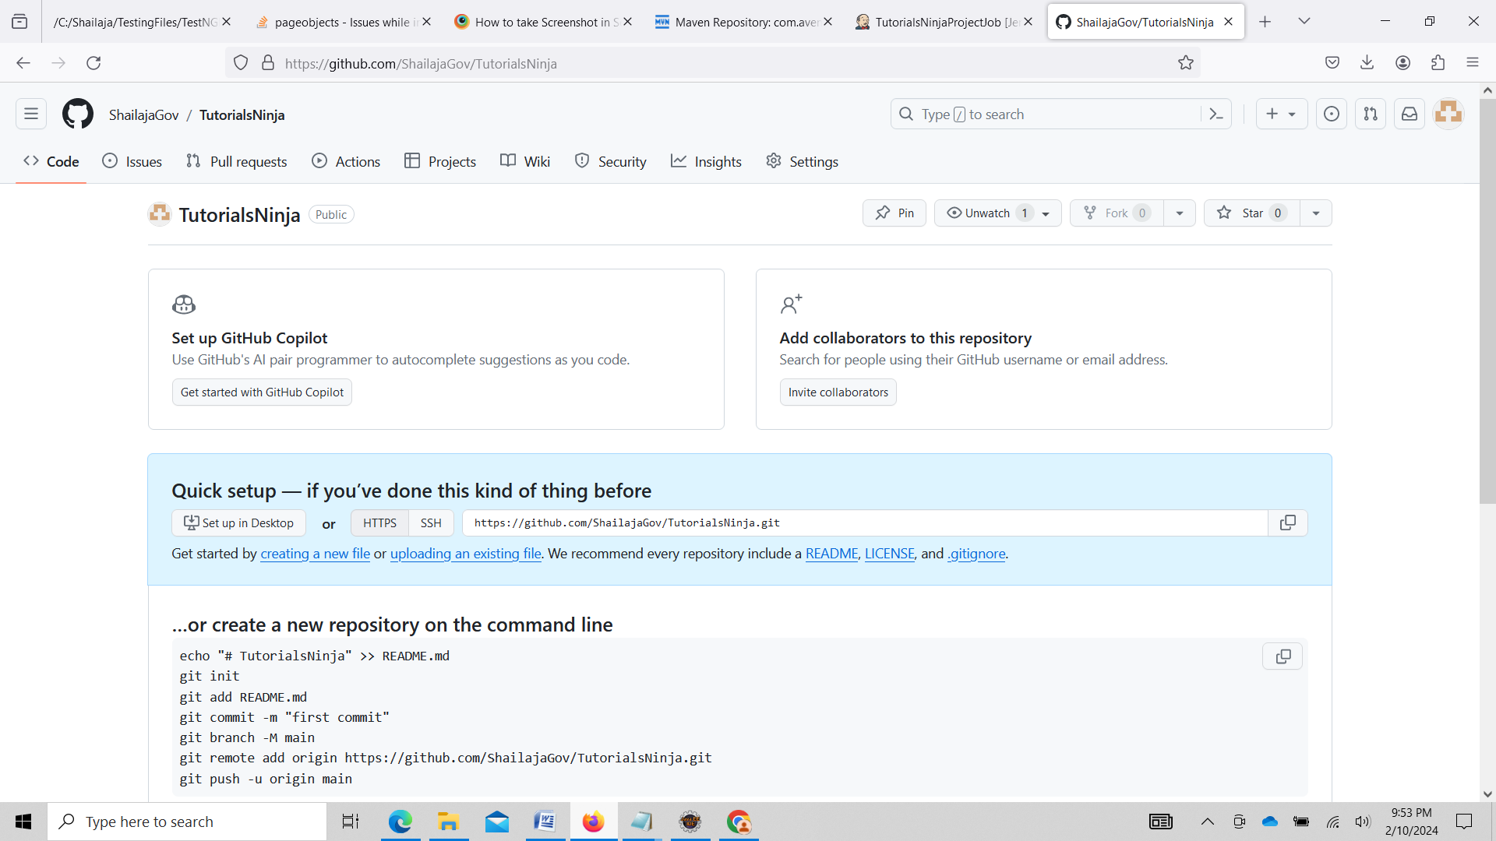

Right click and Select Team->Remote->Push

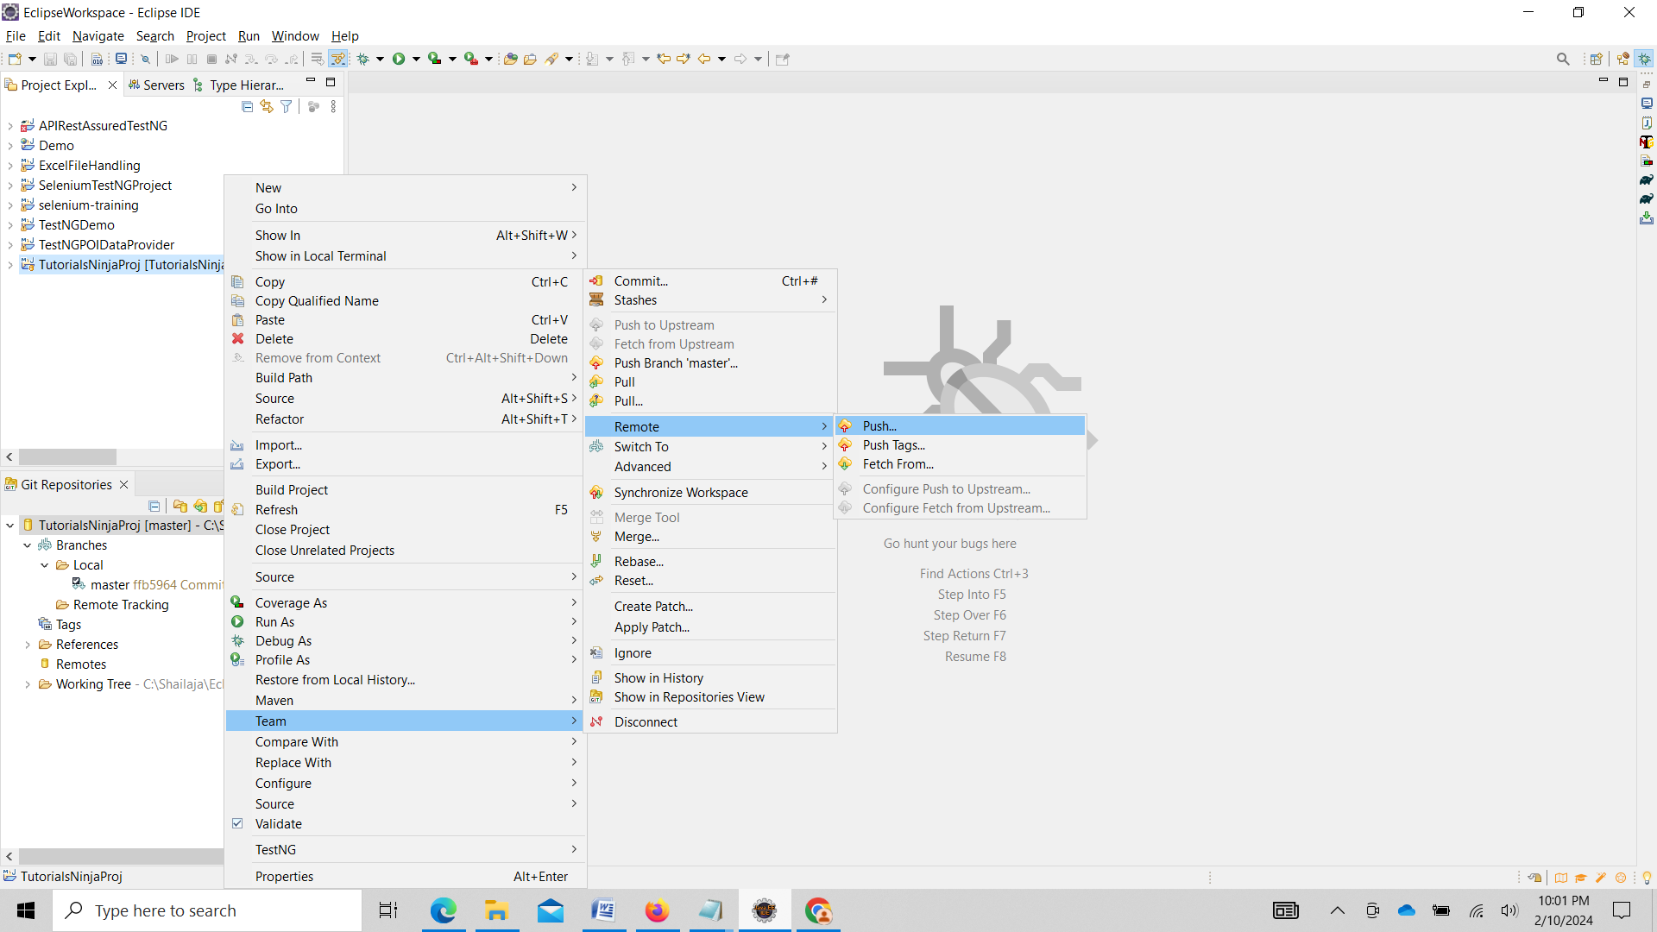

Enter Git Rpository <https://github.com/ShailajaGov/TutorialsNinja.git>

in URI

Go to <https://github.com/settings/tokens>

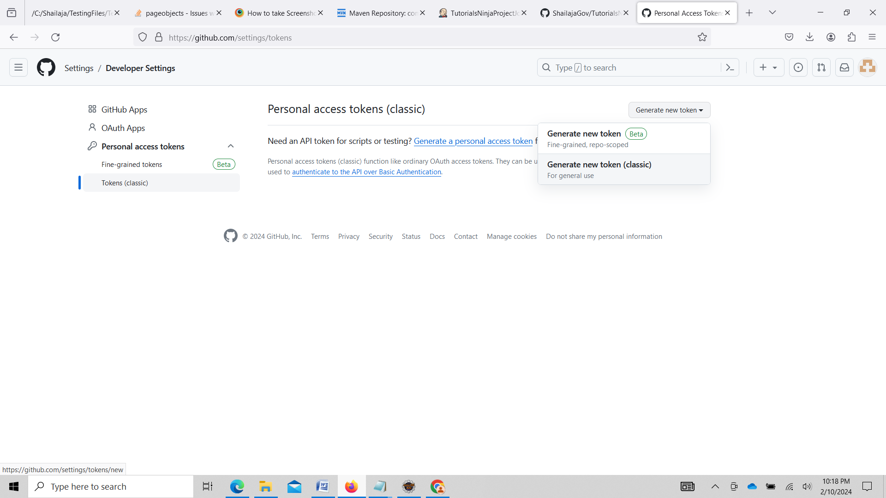

Enter Note and select repo check box and Click Generate token

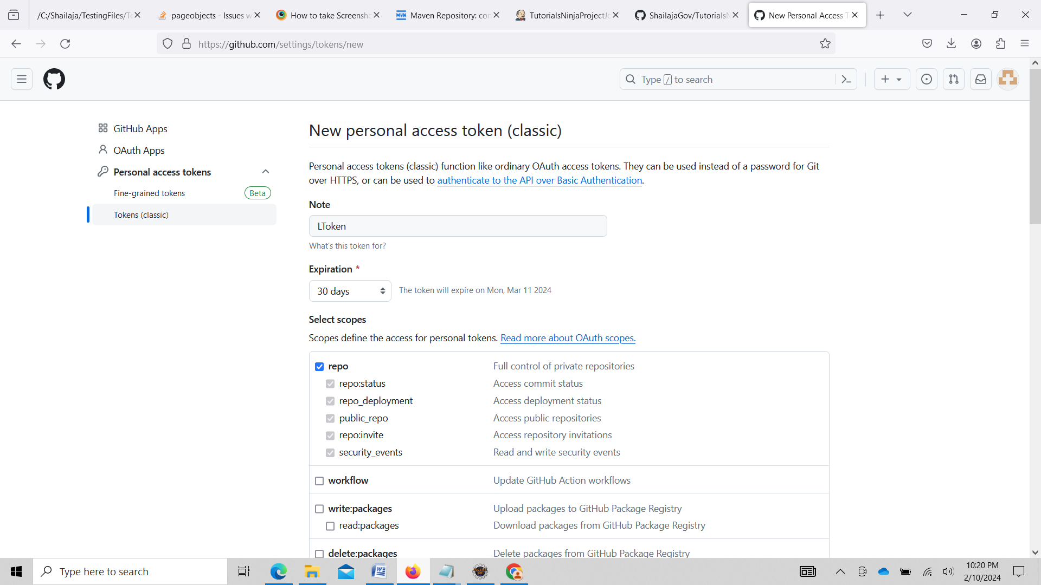

Enter username and password of GitHub an click on Next

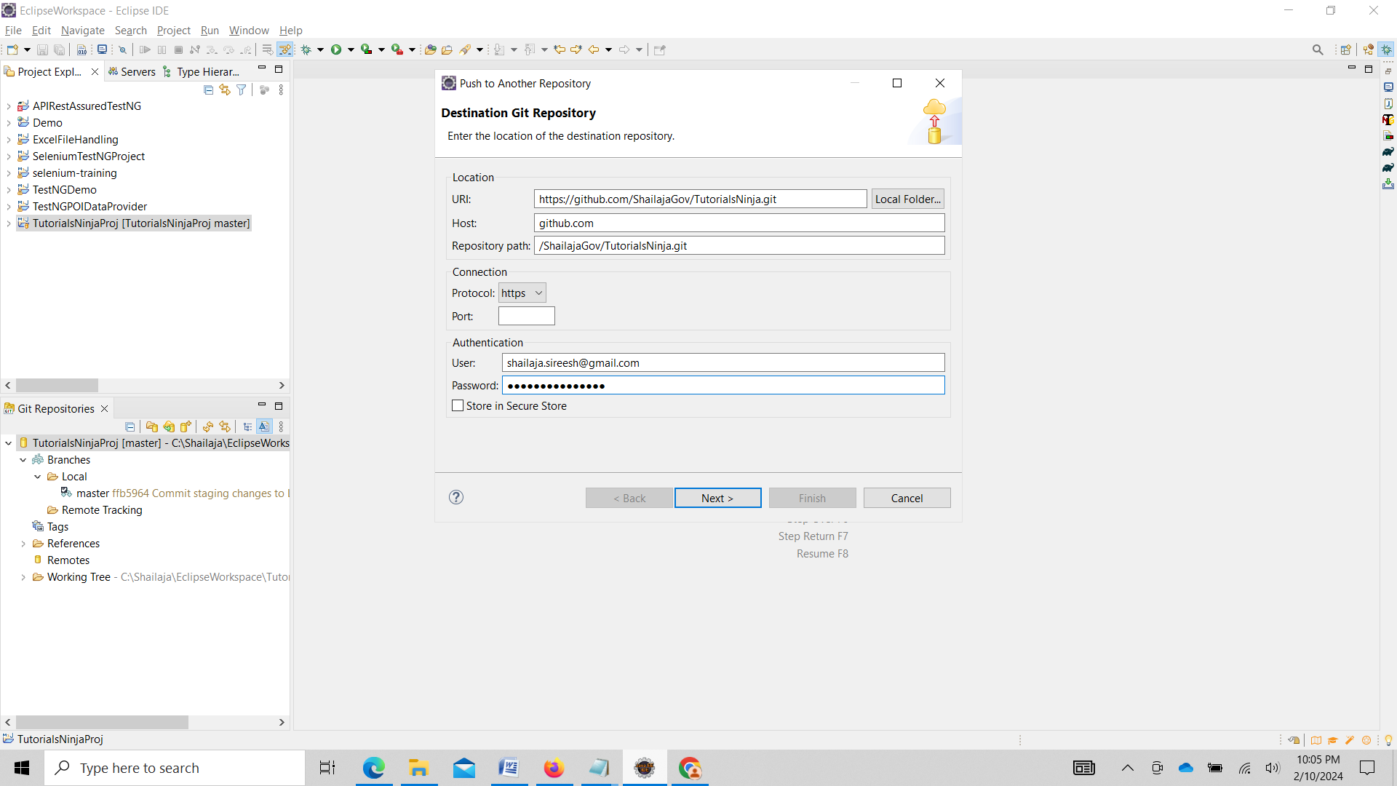

Select master in Source ref and Click on Add Spec

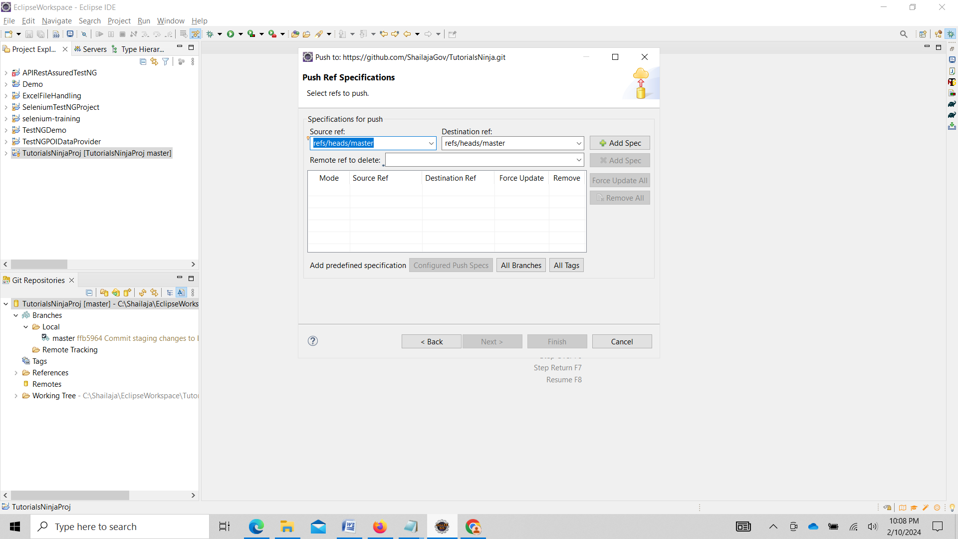

Select checkbox under Force Update and Click on Finish

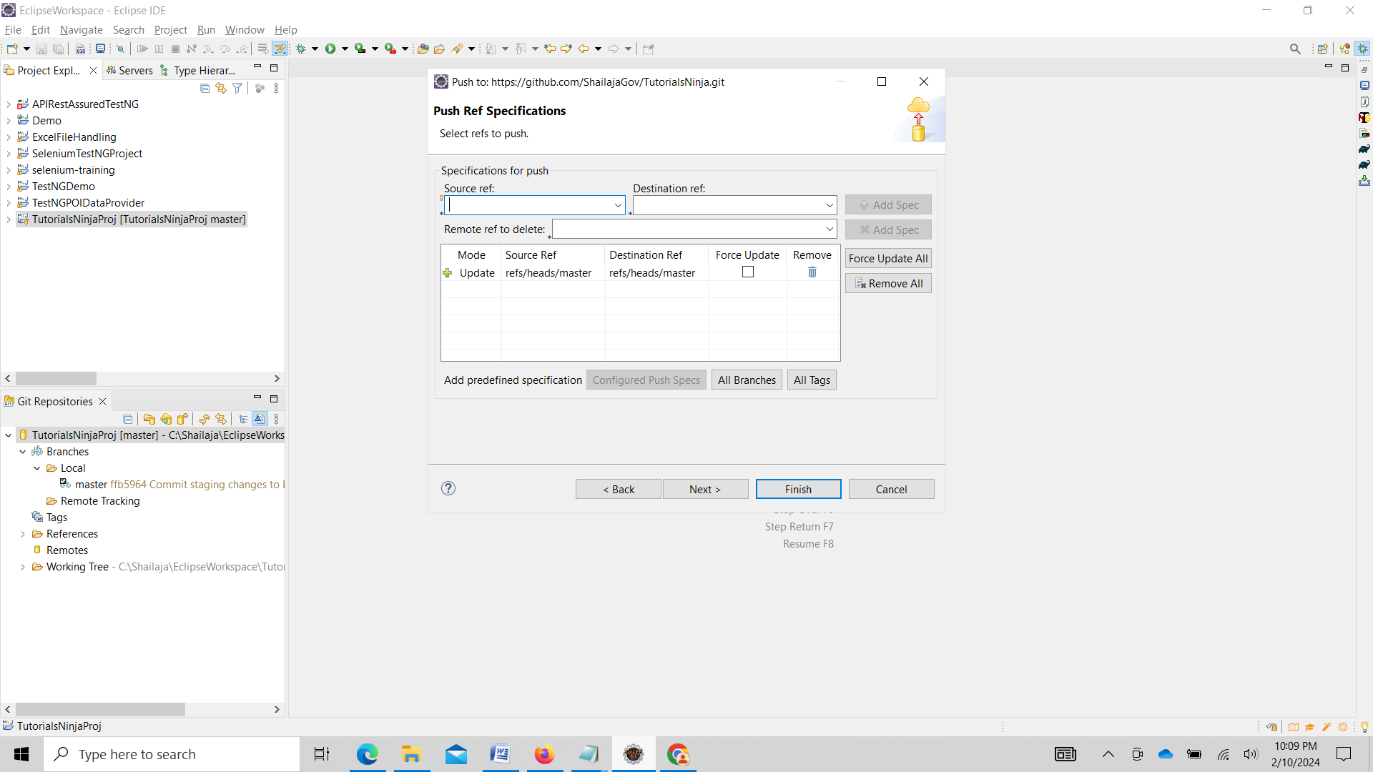

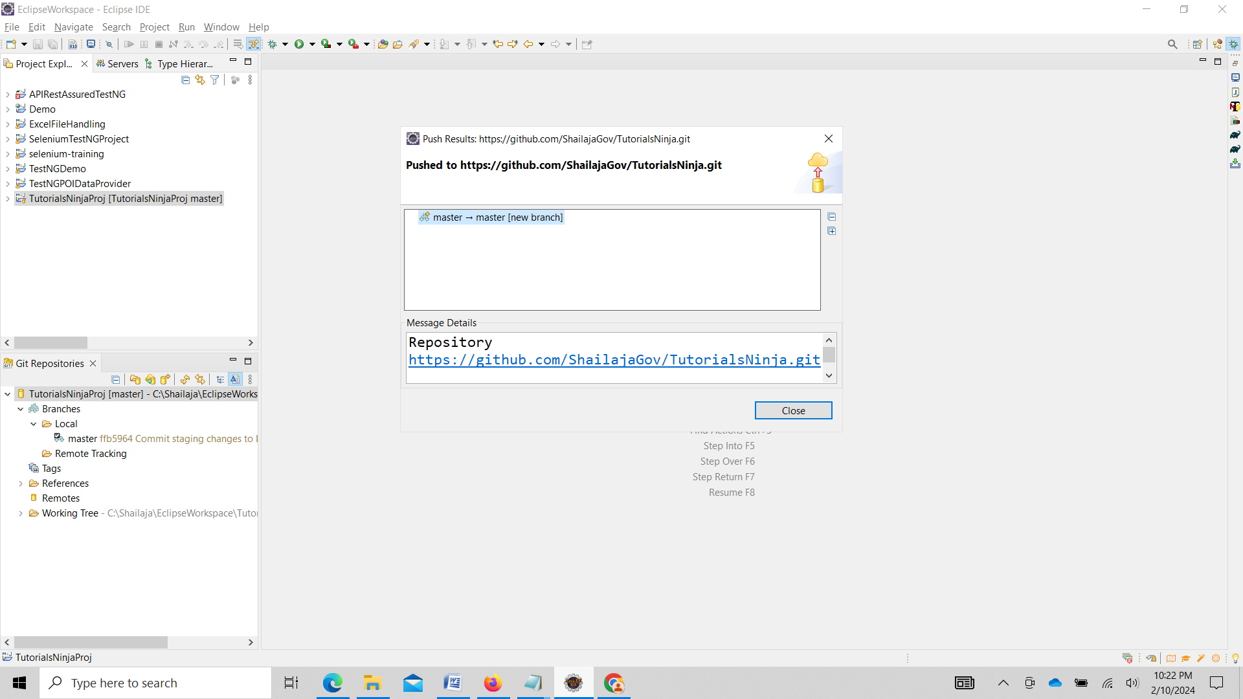

Check GitHub repository now <https://github.com/ShailajaGov/TutorialsNinja.git>

Local Repo changes gets pushed to GitHub Repo

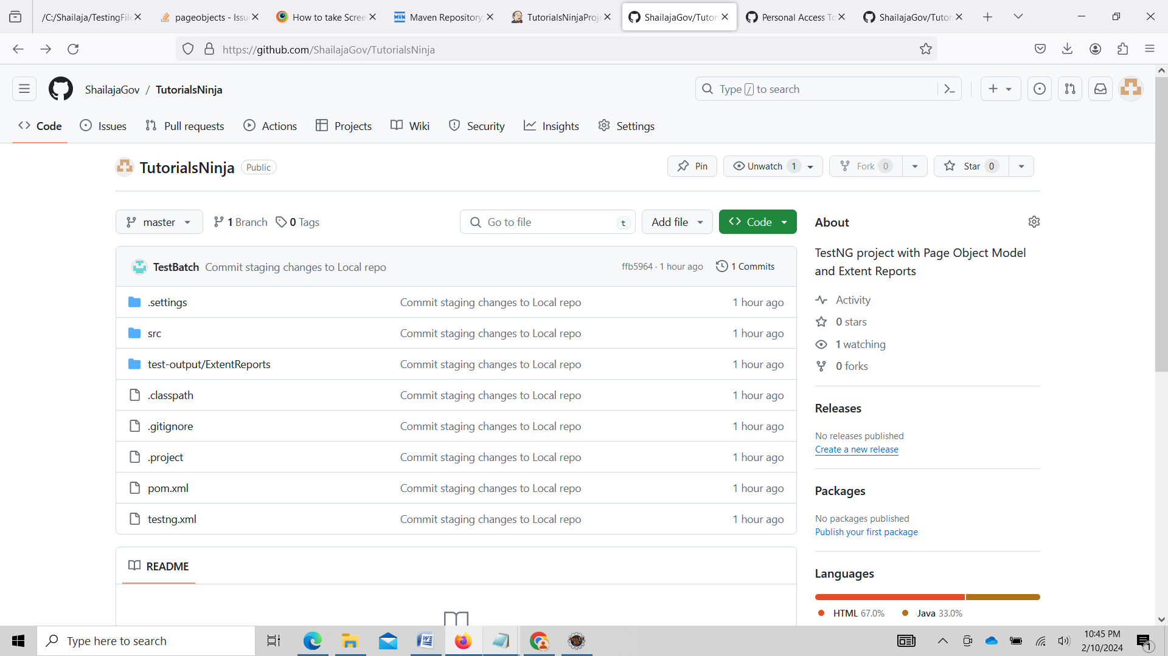

Switch Workspace to Team member workspace

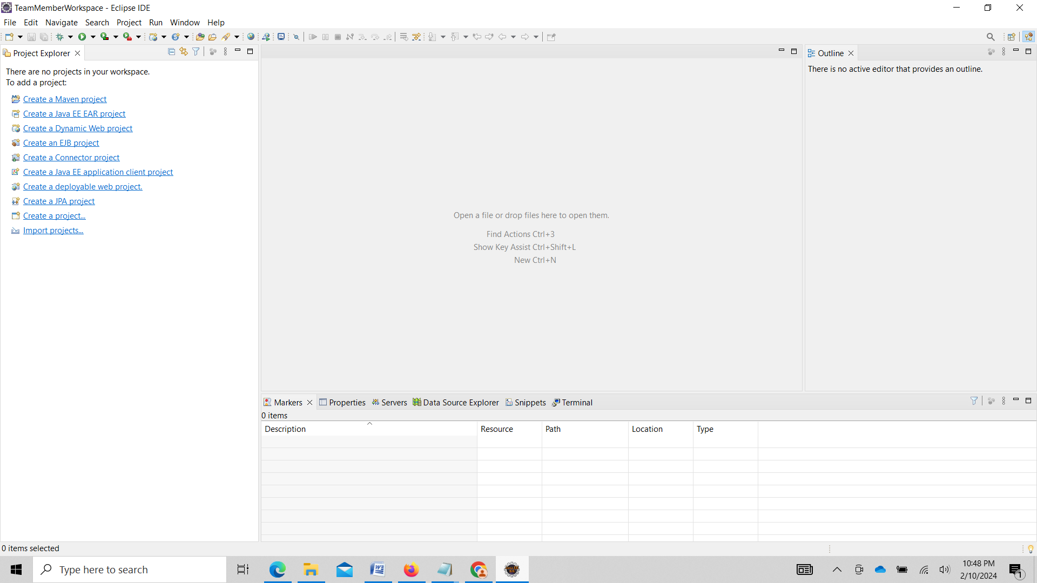

Search for Git and add Git Repositories and Select Clone a Git Repository

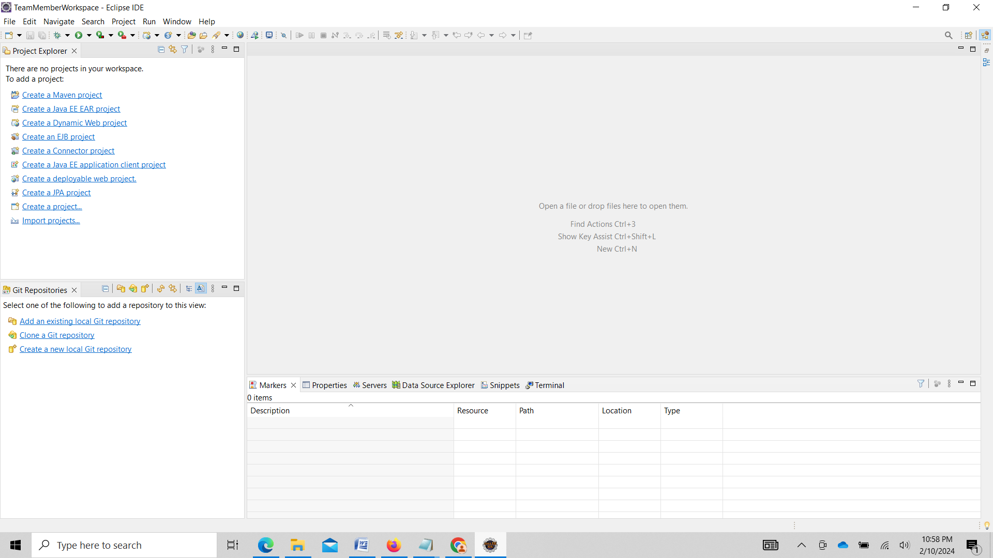

Click on Clone URI

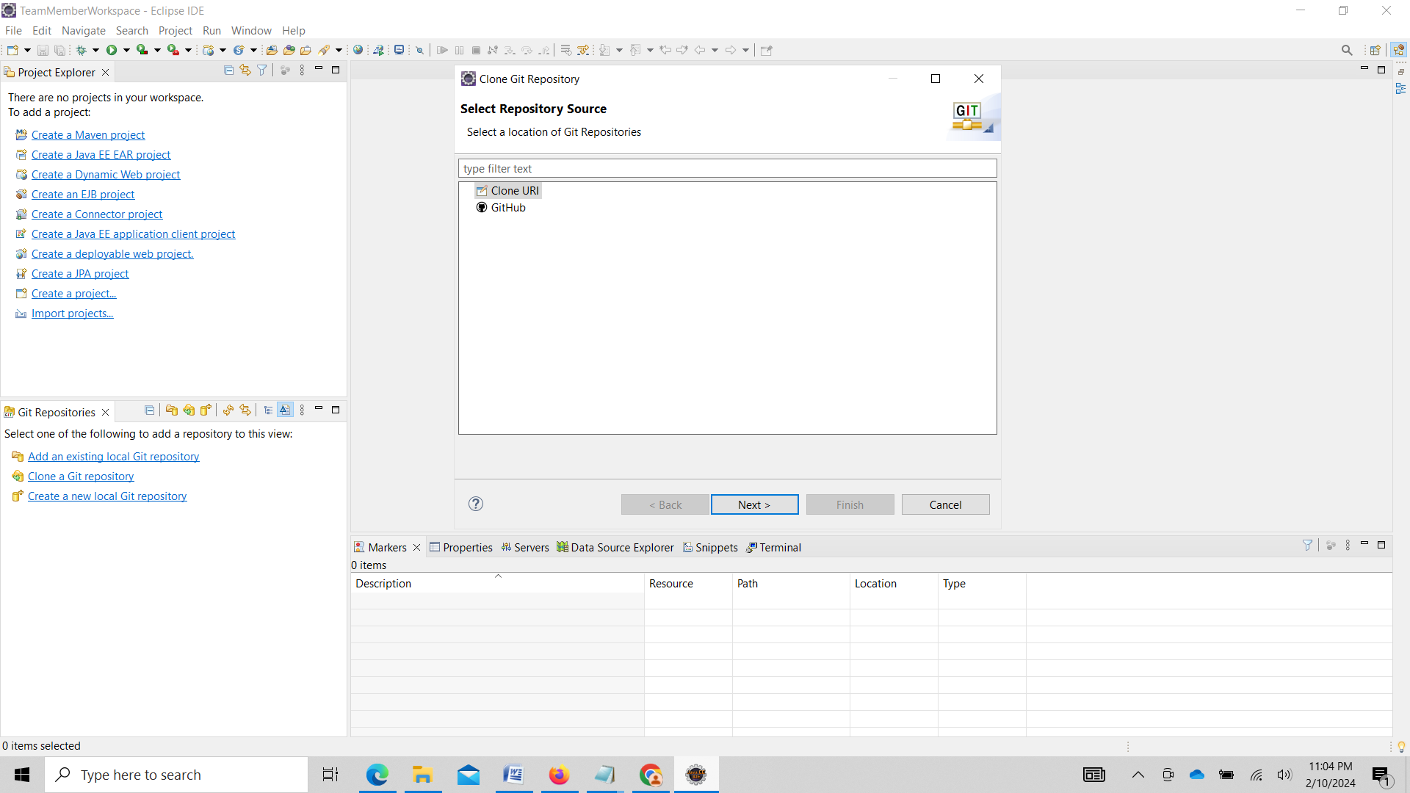

Click on Clone URI and Enter GitHub Repo link 

Enter user name and user token

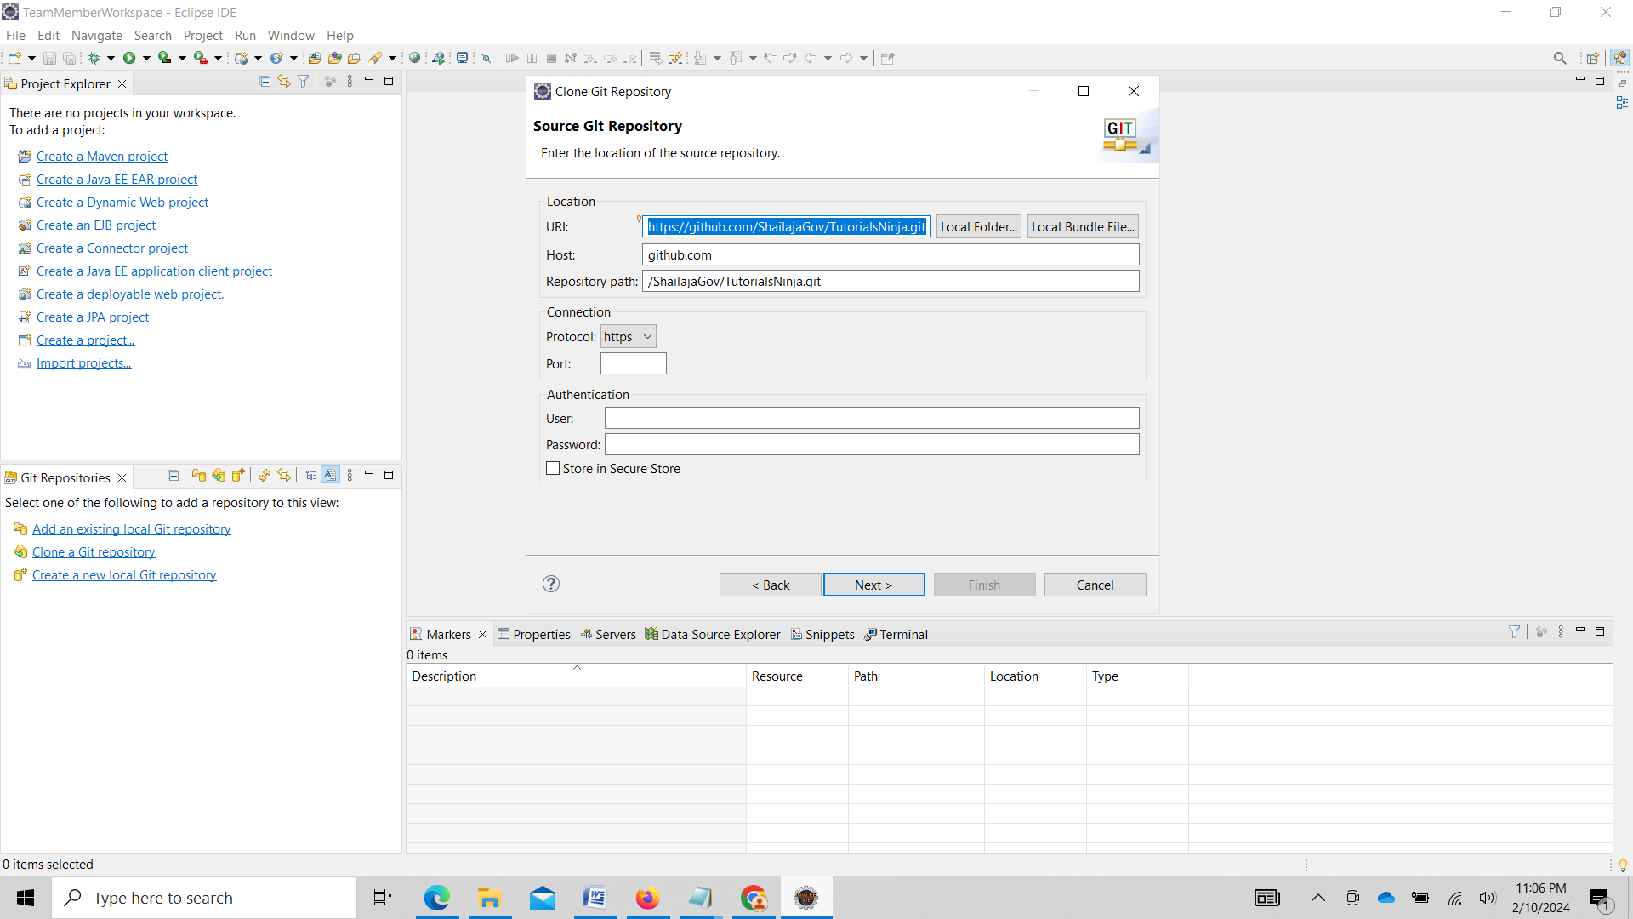

Signup in GitHub

Username sailu_saila@yahoo.co.in

Gitpassword@123

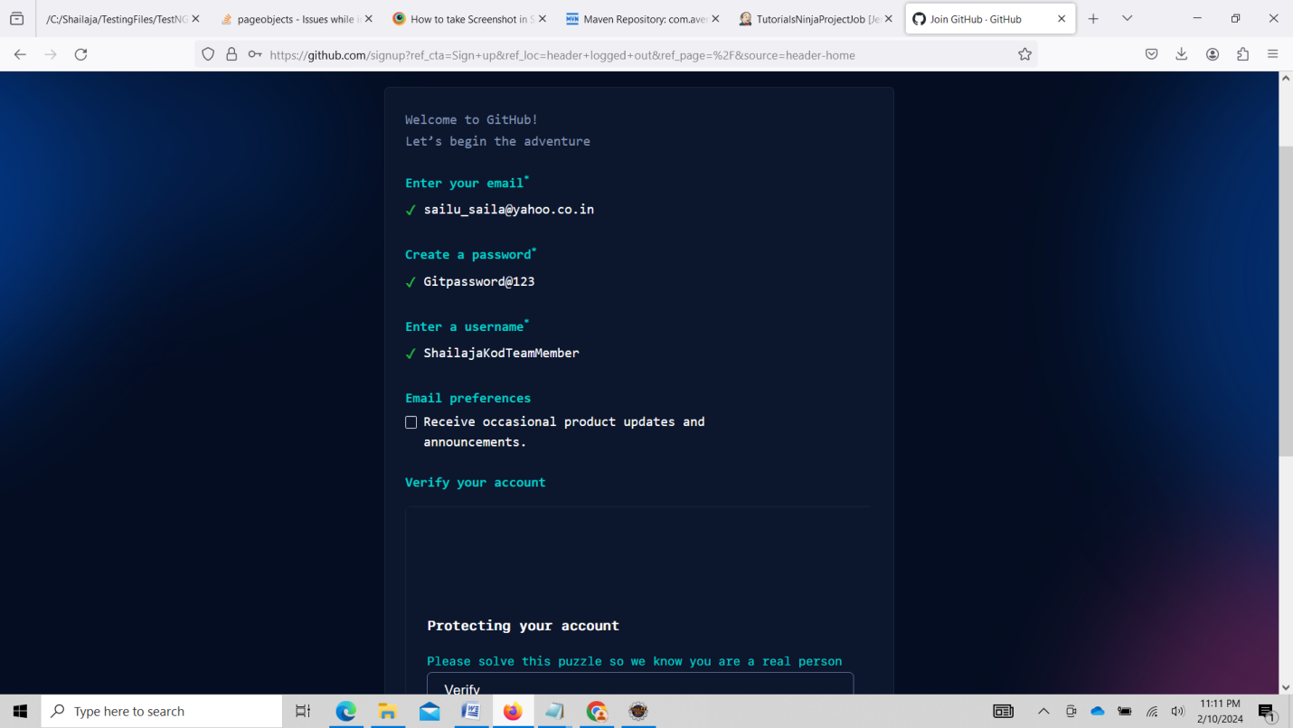

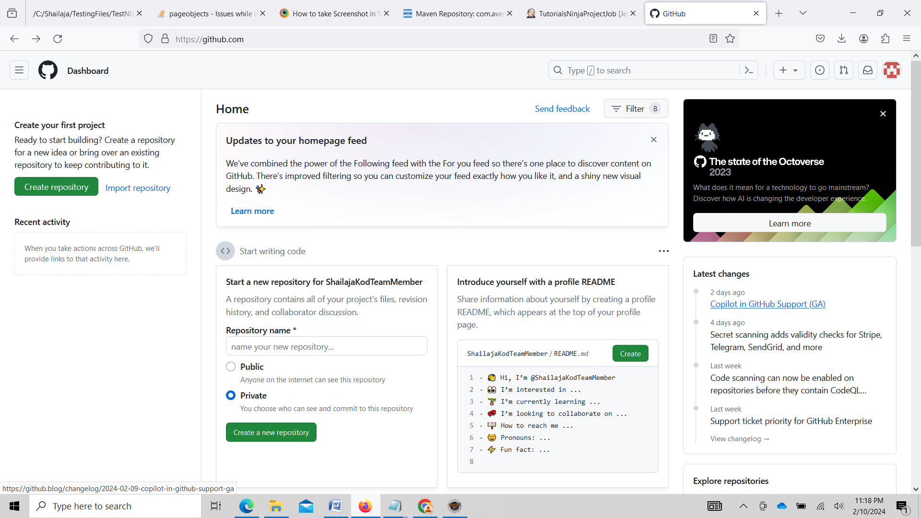

Got To Eclipse

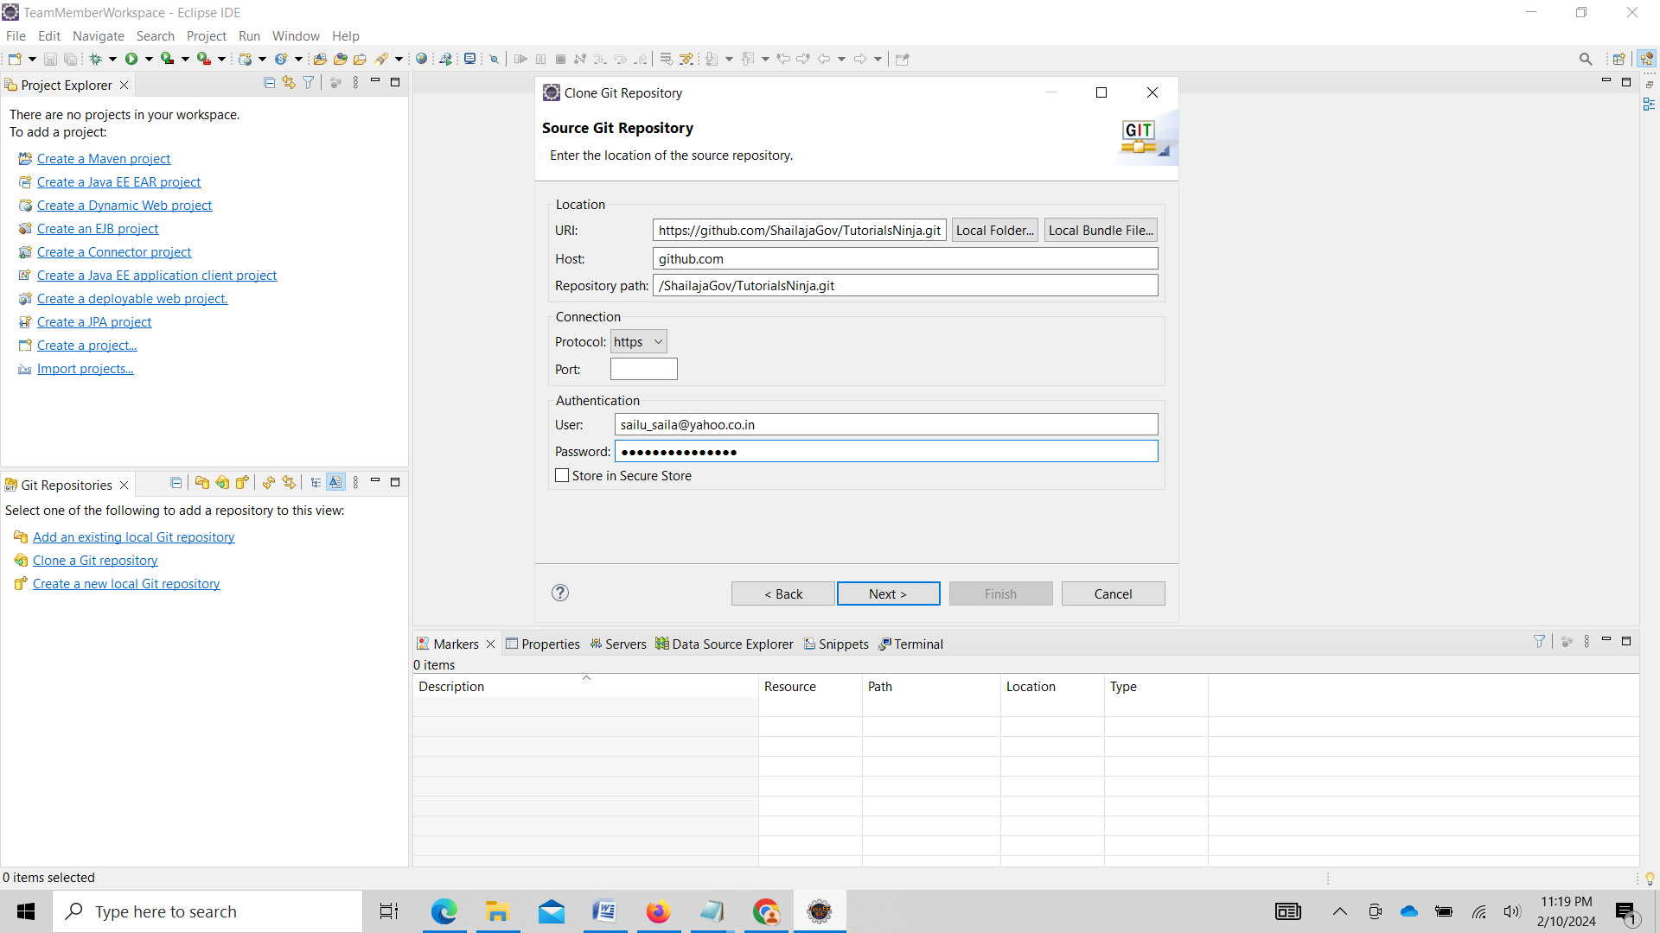

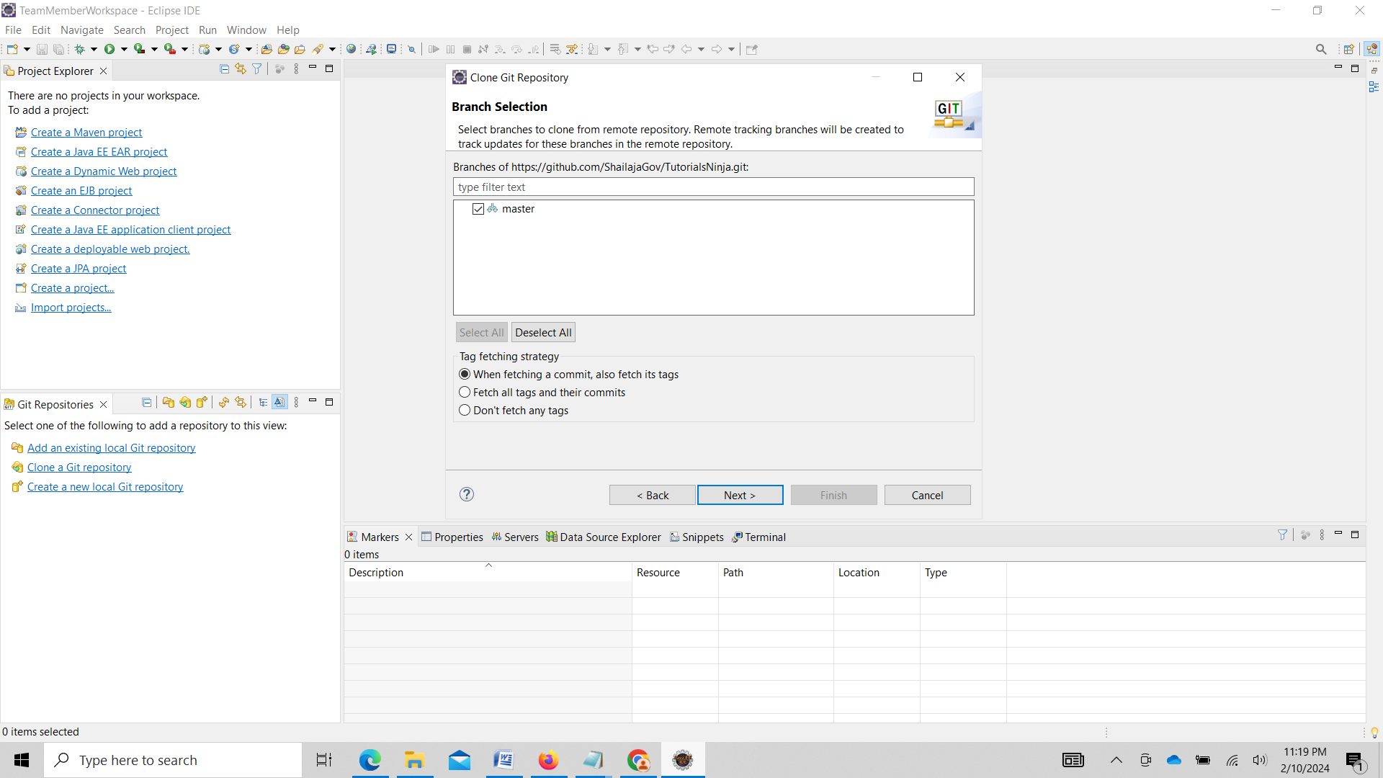

Select master and click on Next

Click on Finish

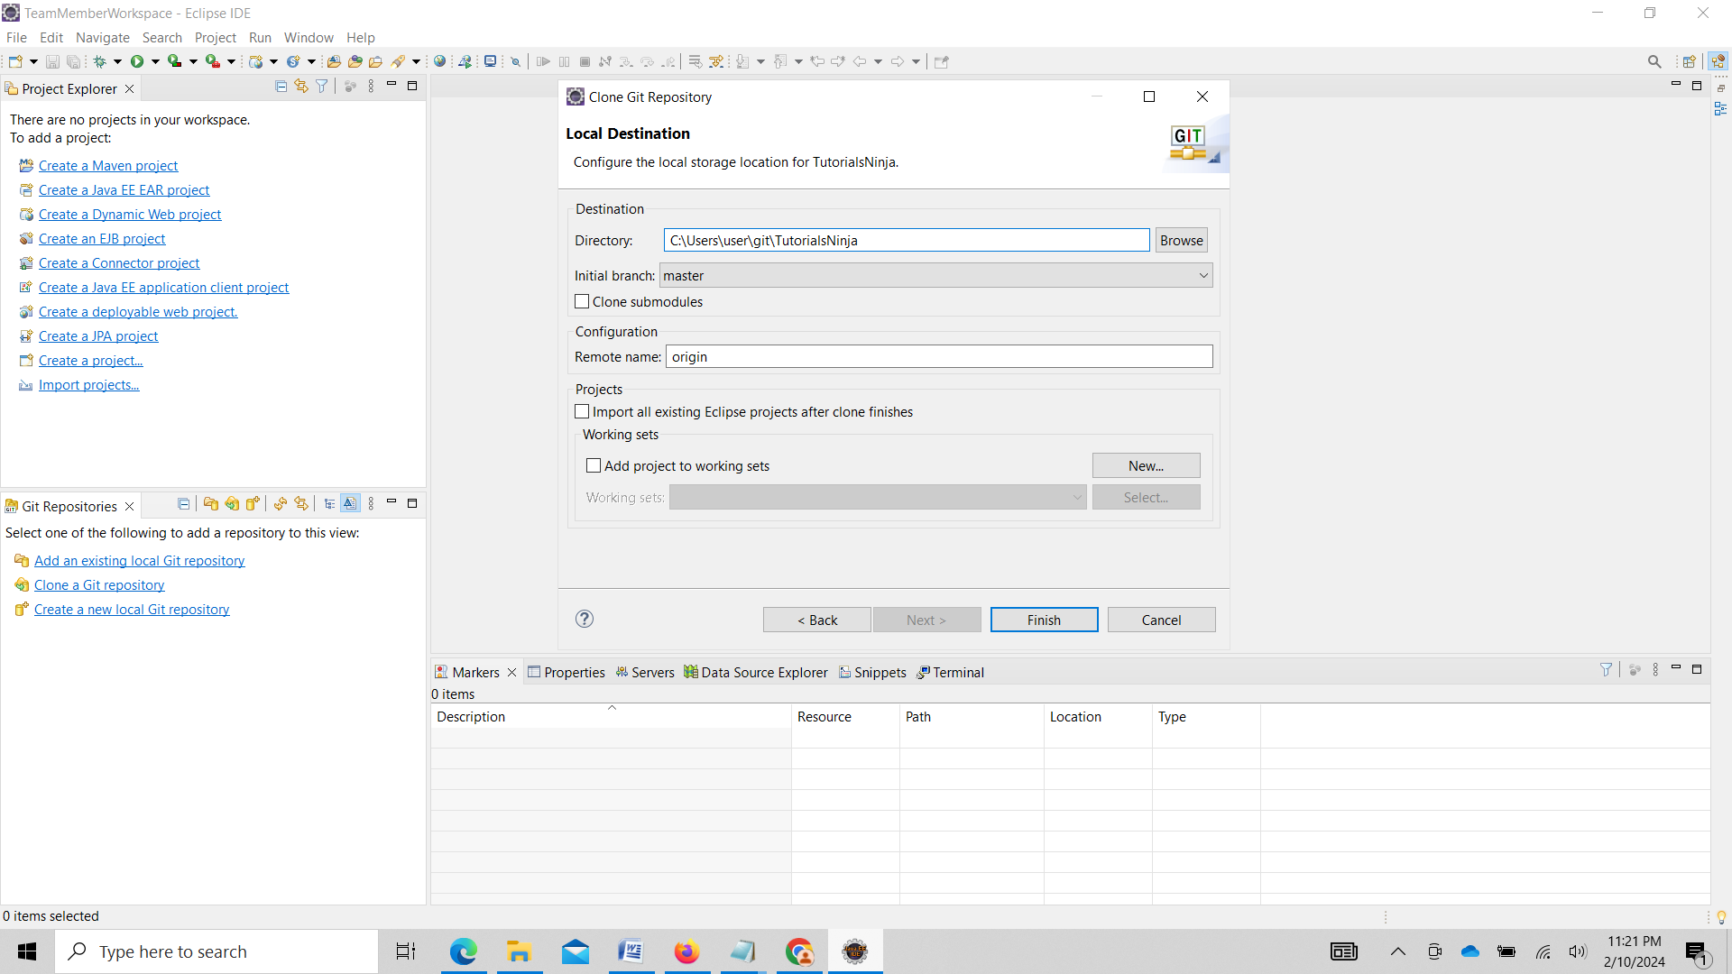

Master branch gets created in Local Repo

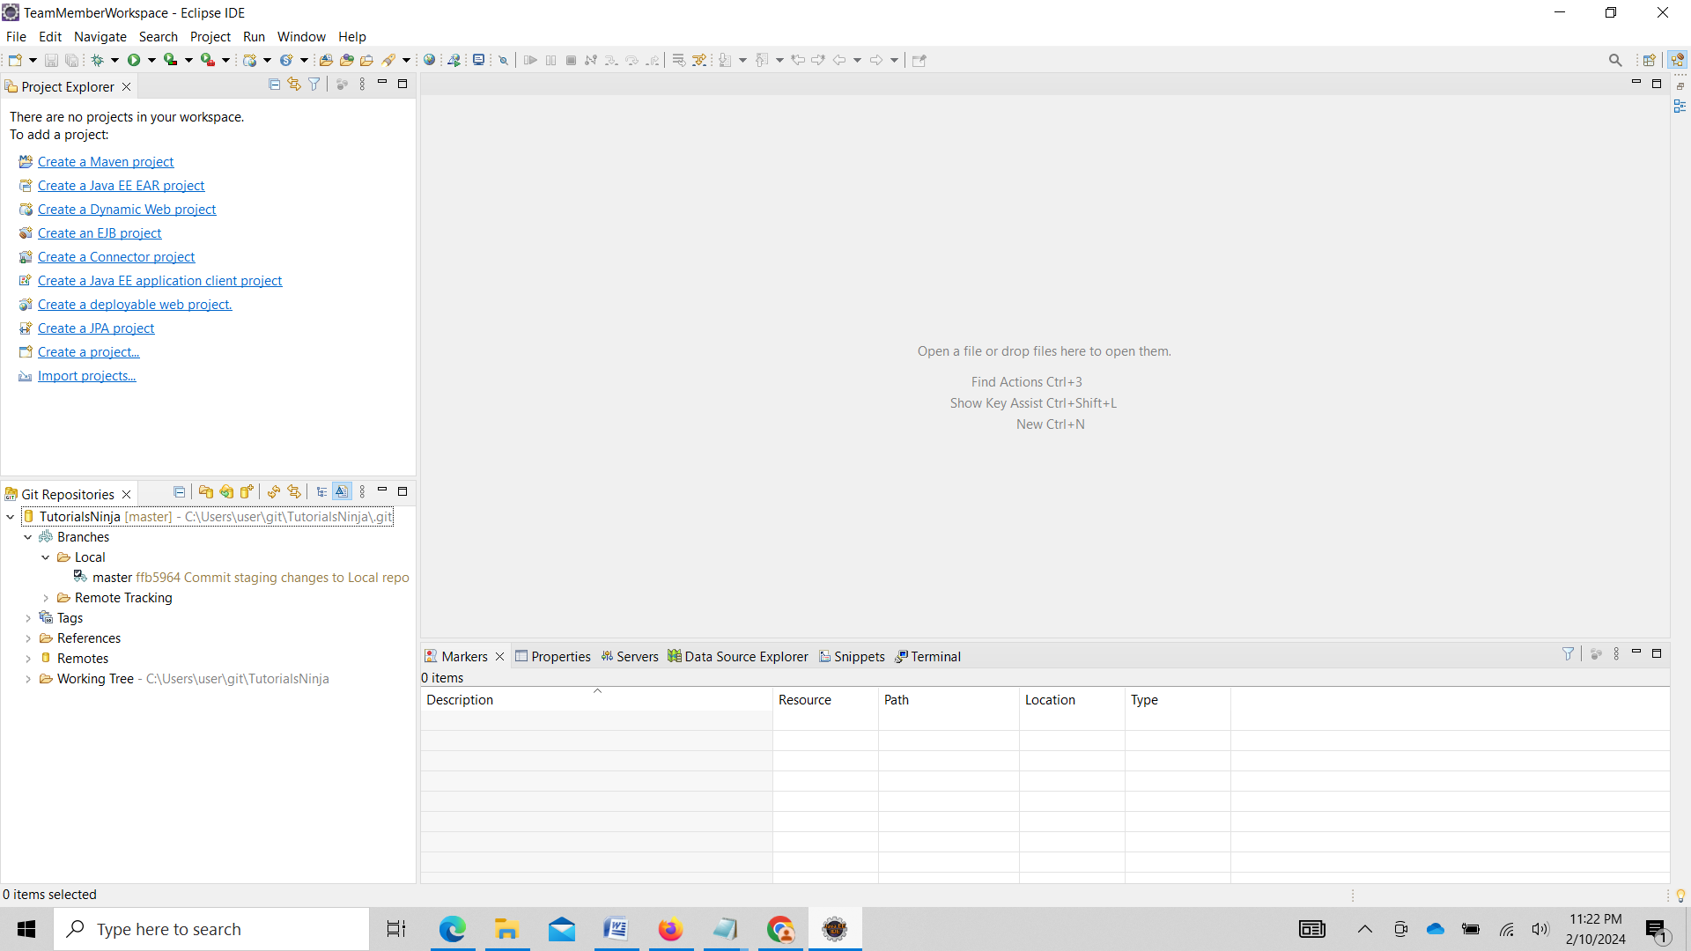

Moving Local Repo into team member Workspace

Select File ->Import

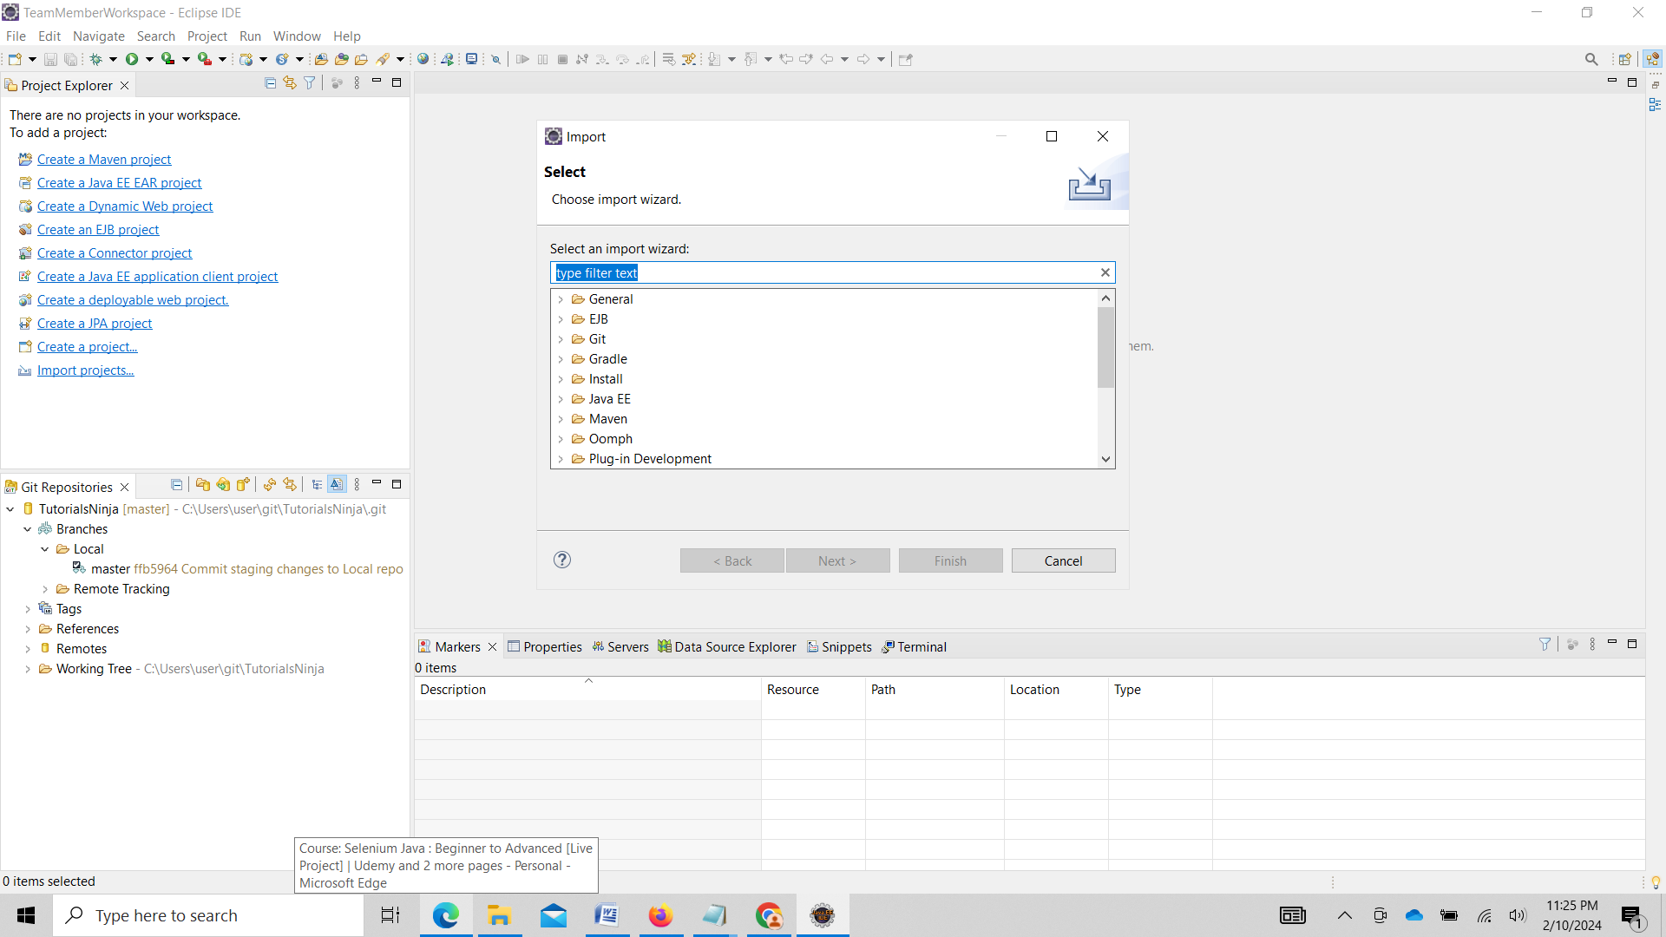

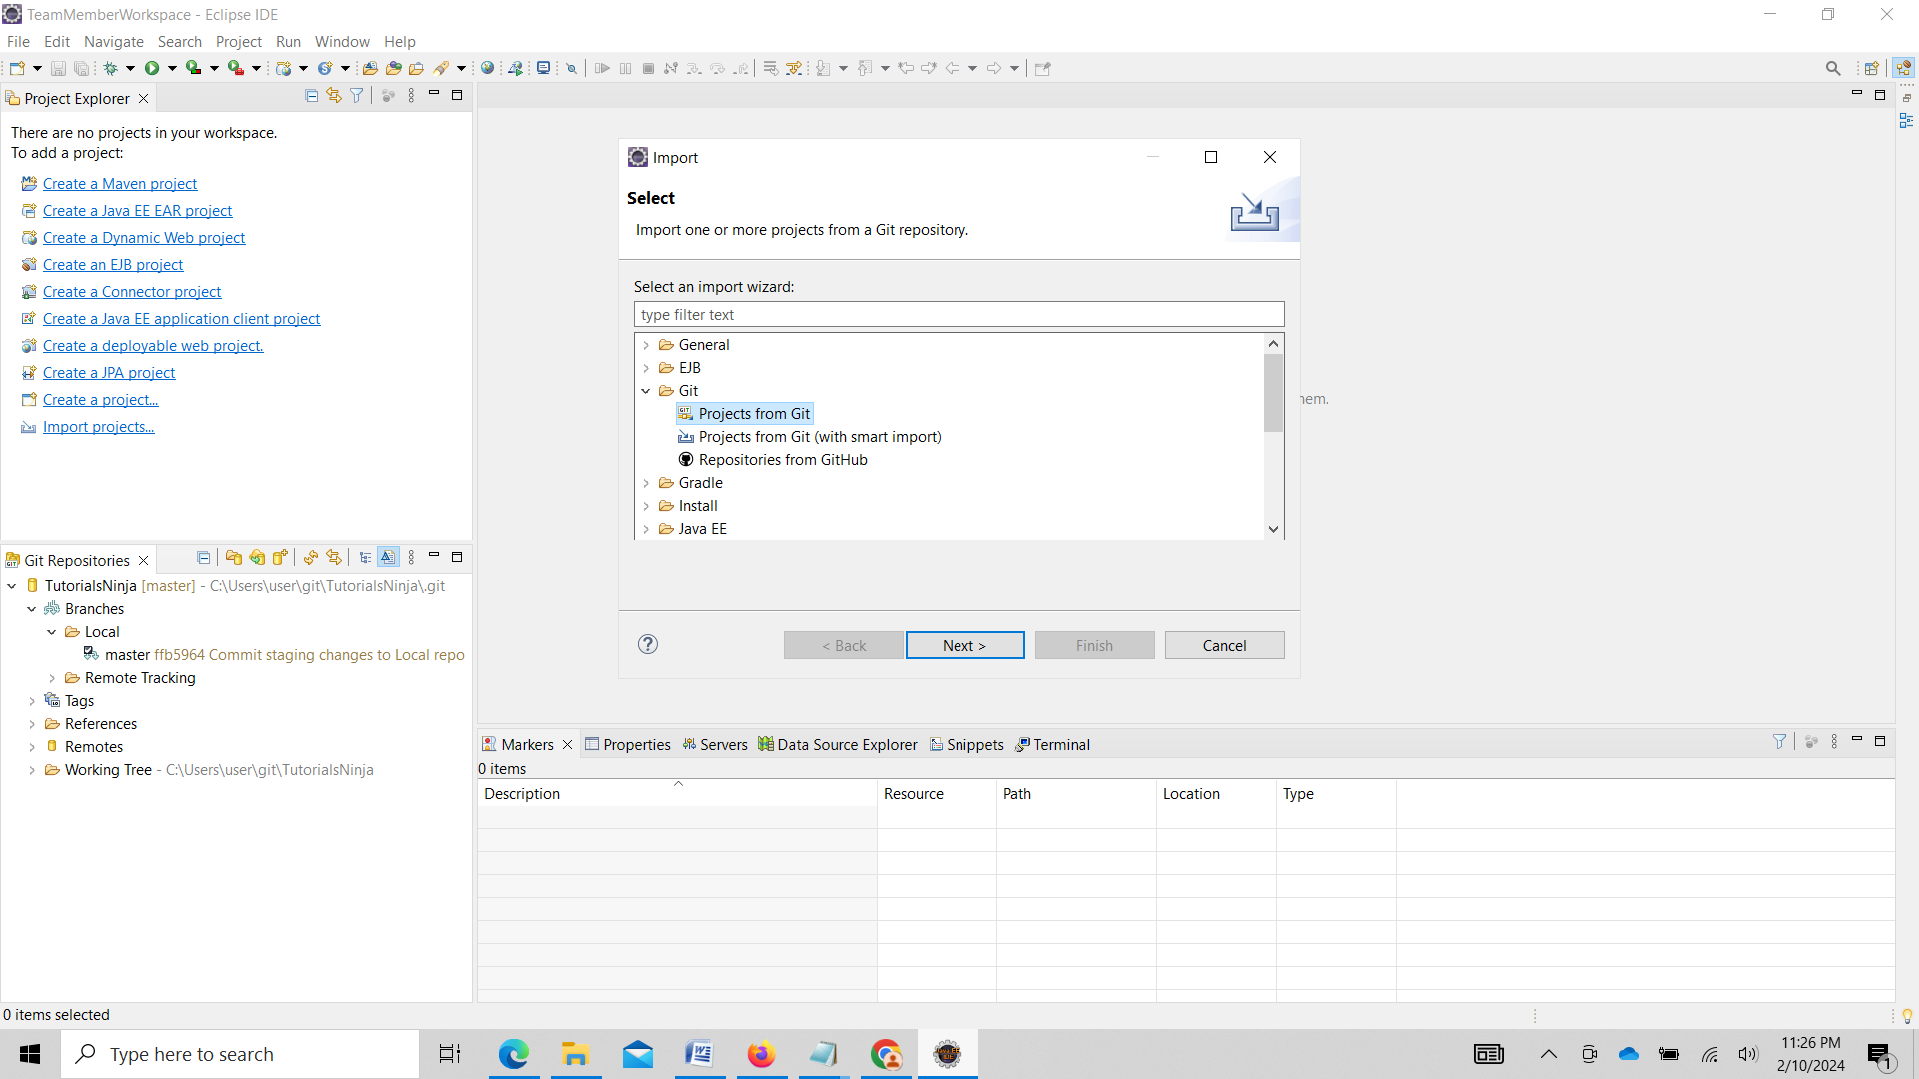

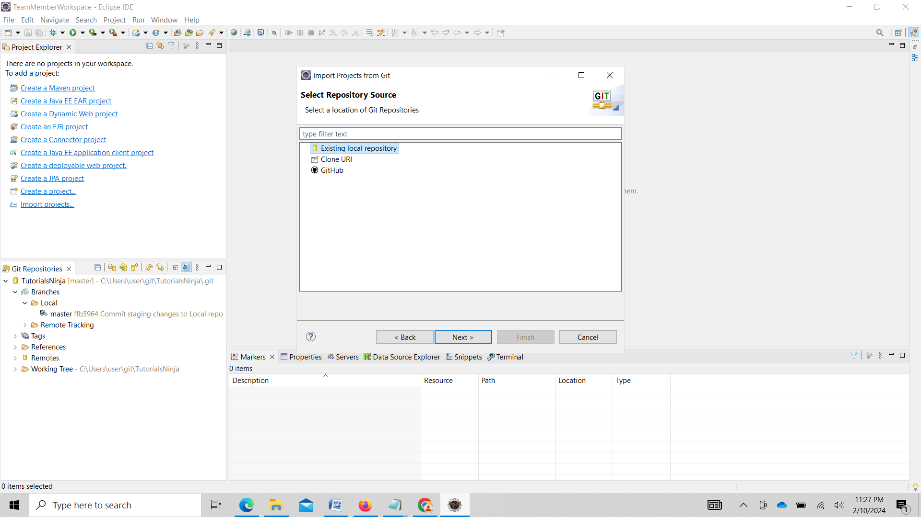

Click on Next

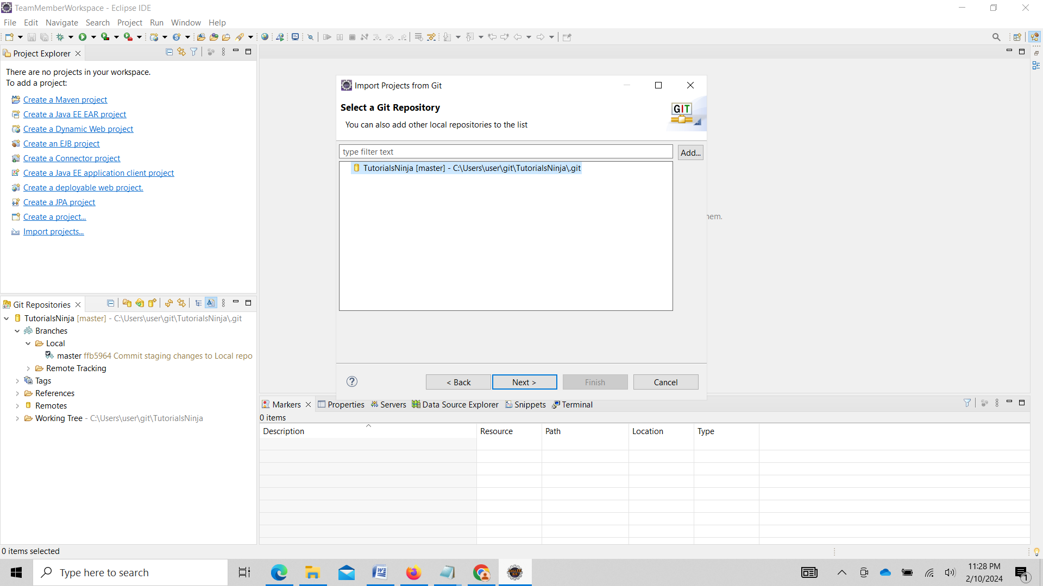

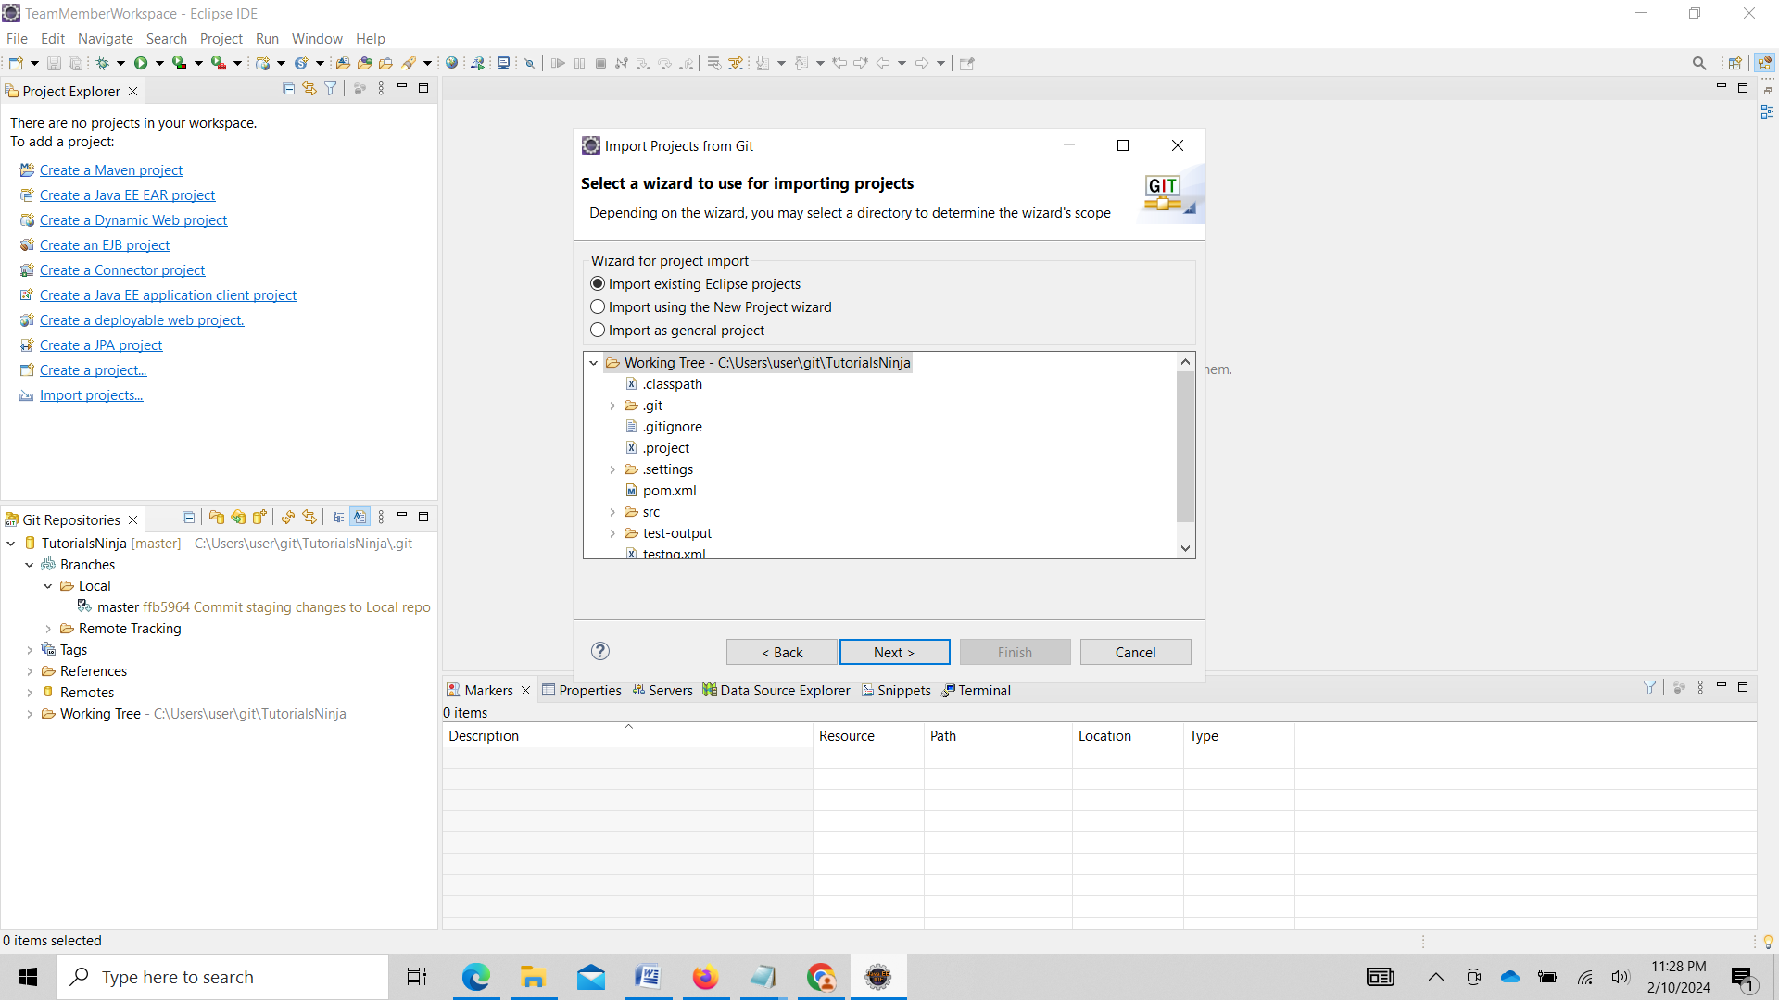

Click on Finish

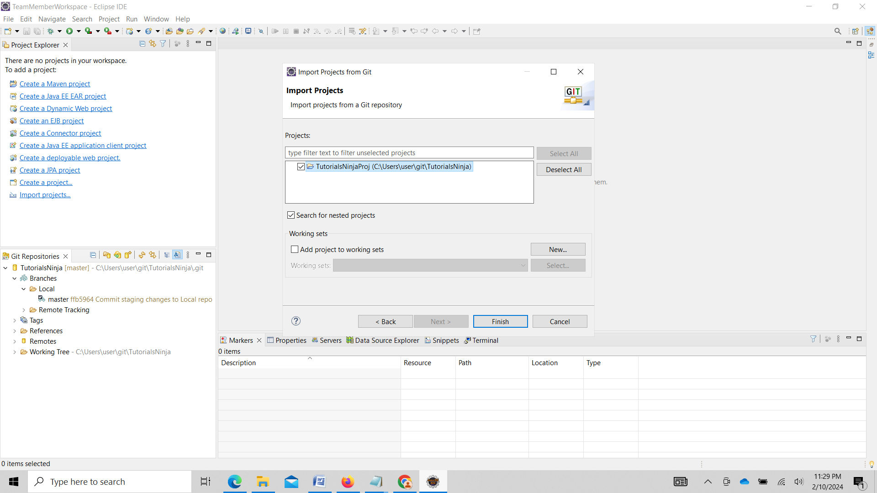

Project appears in Team members workpace

Update SearchTest file with some comments.

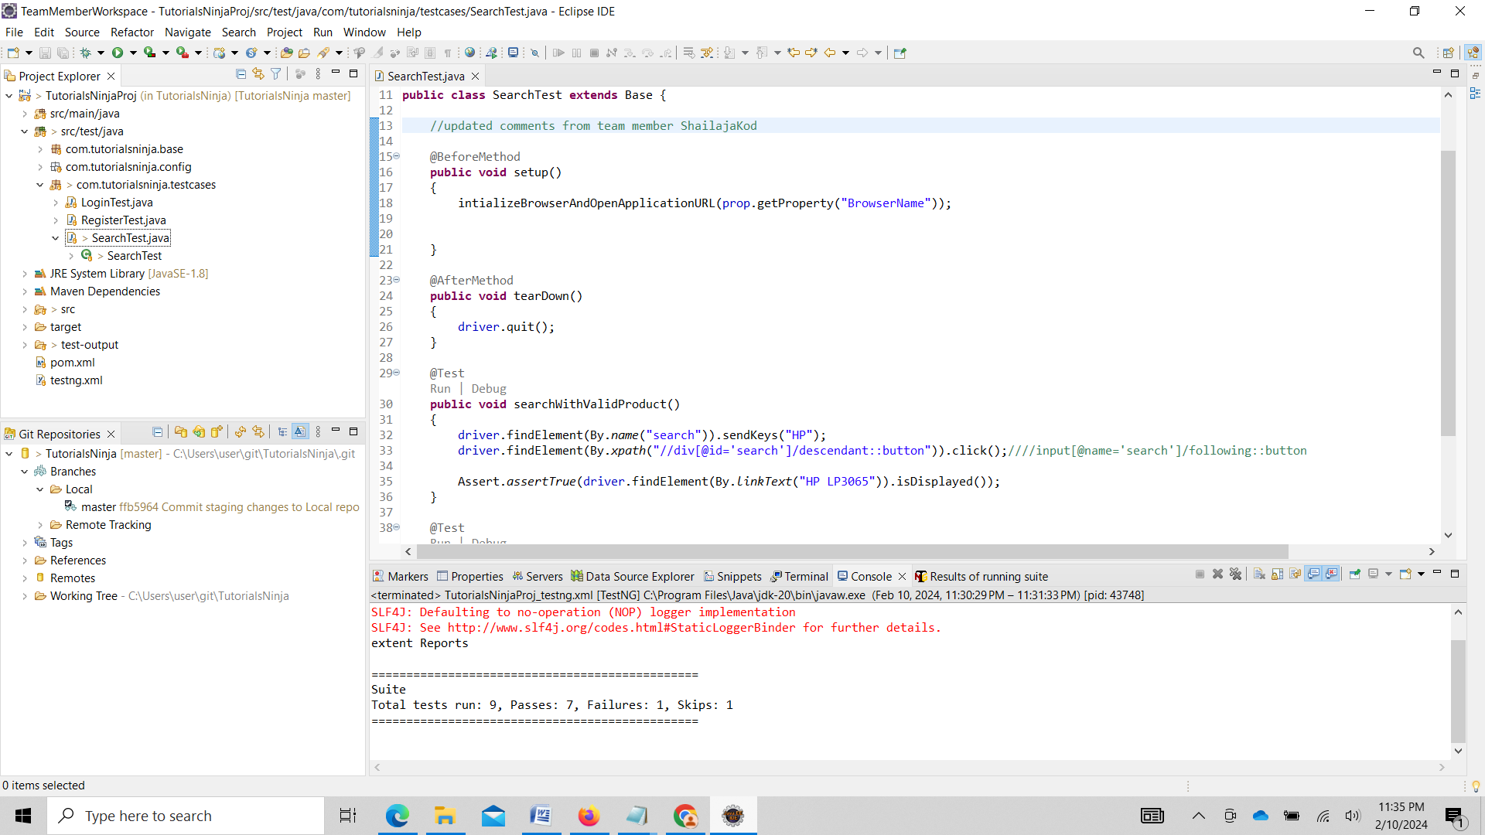

After updating Move changes to staging area

Team->Add to Index

Create a new branch in Local Repo

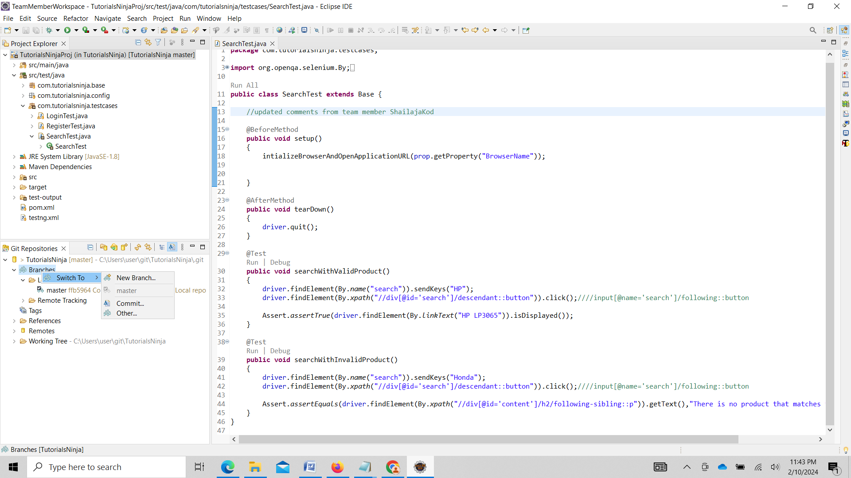

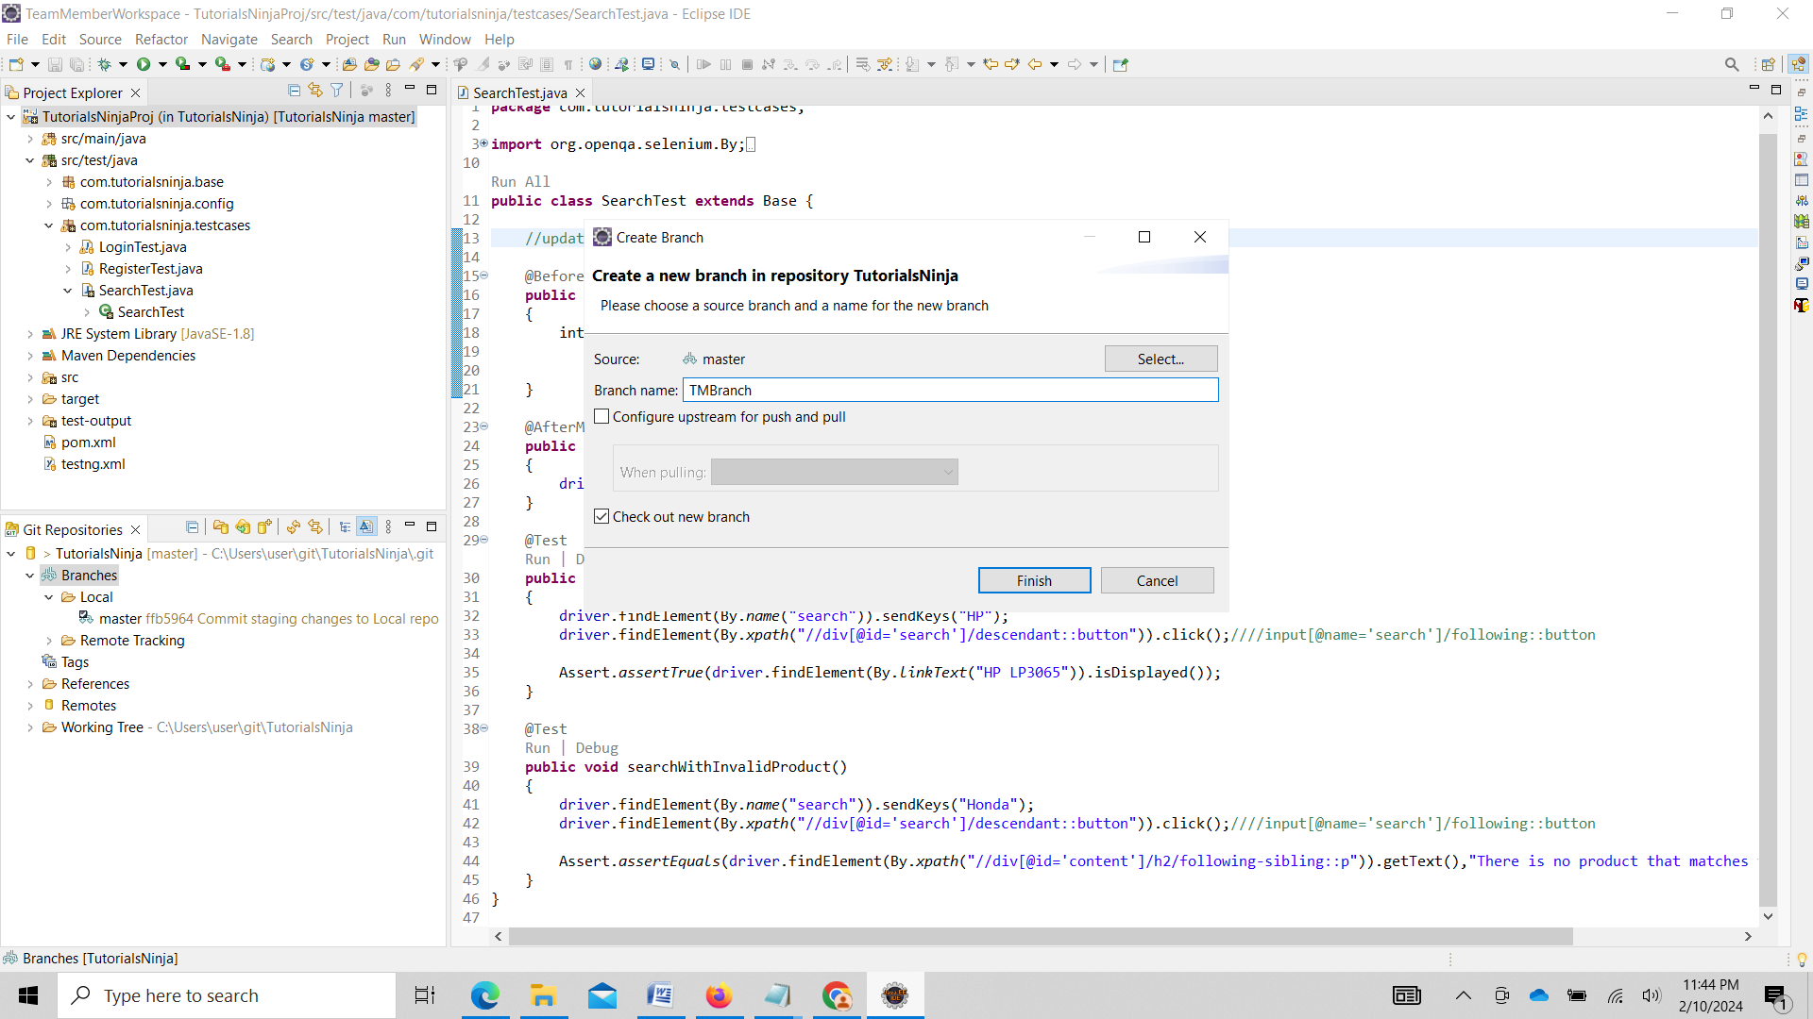

Move changes to TMBranch in local repo

Select Team->Commit

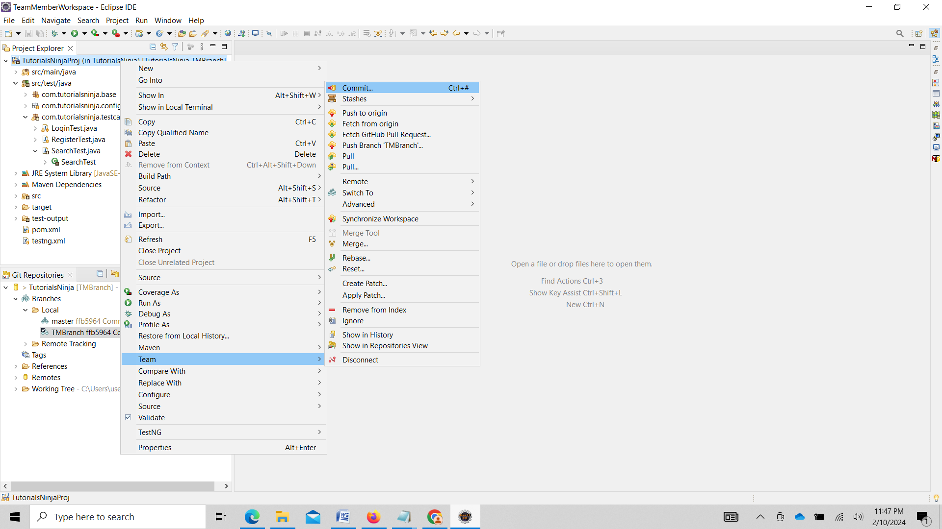

Click on Commit after entering comments

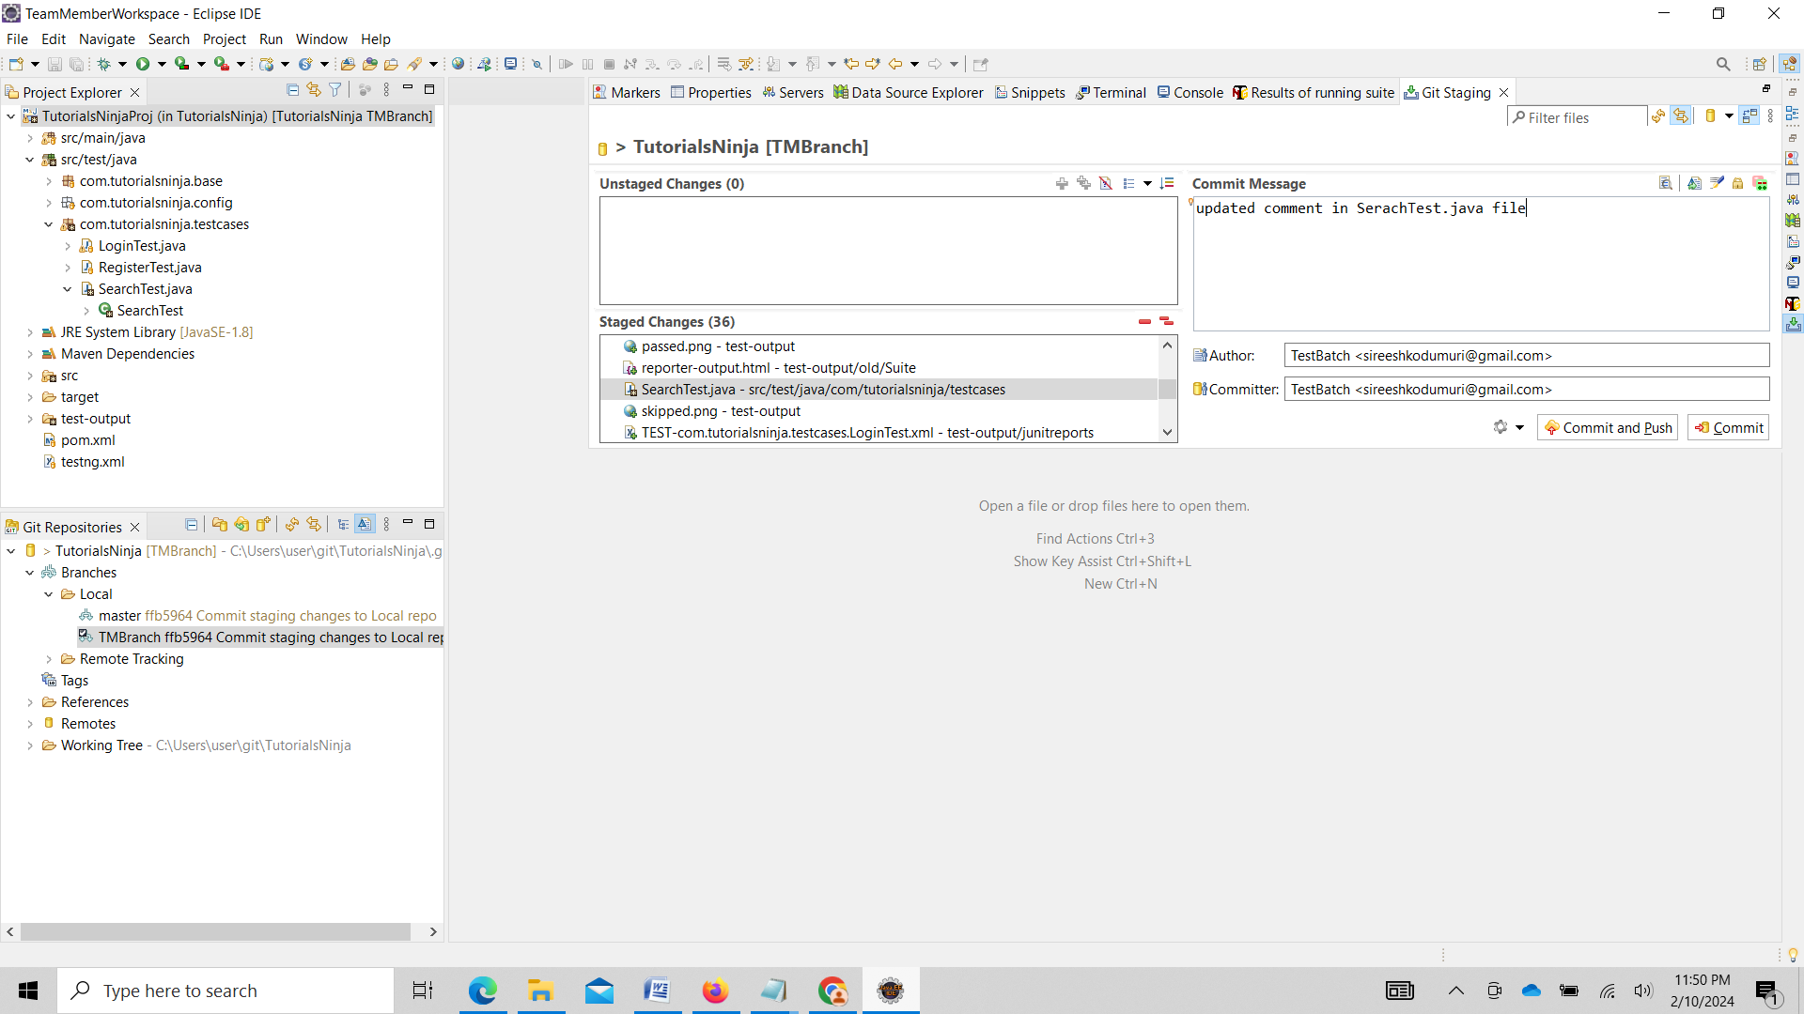

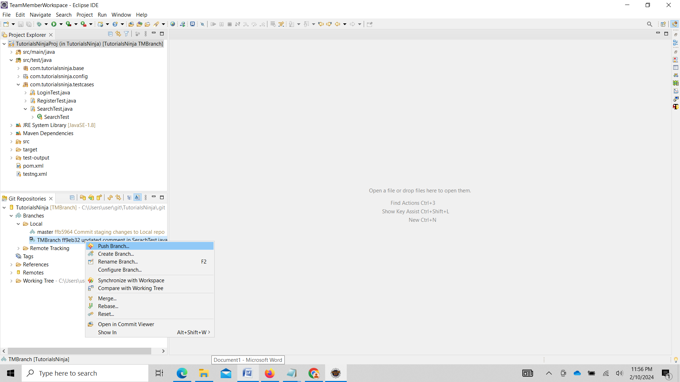

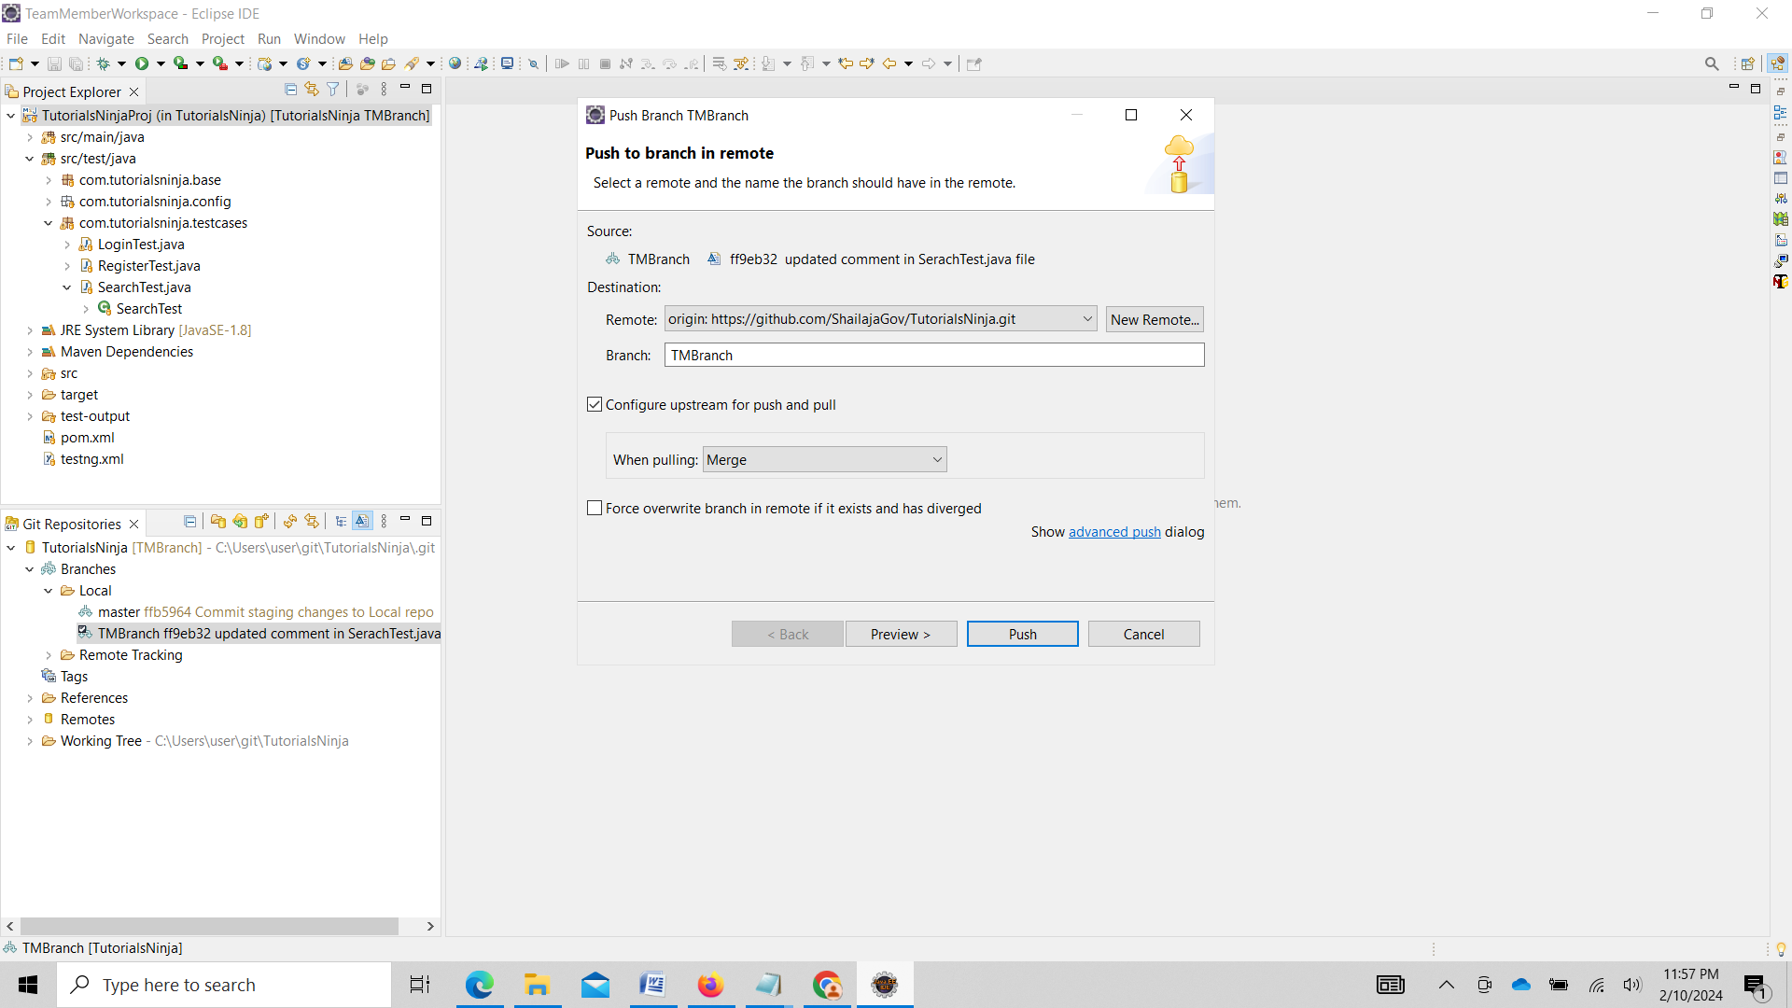

Enter Github credentials and push

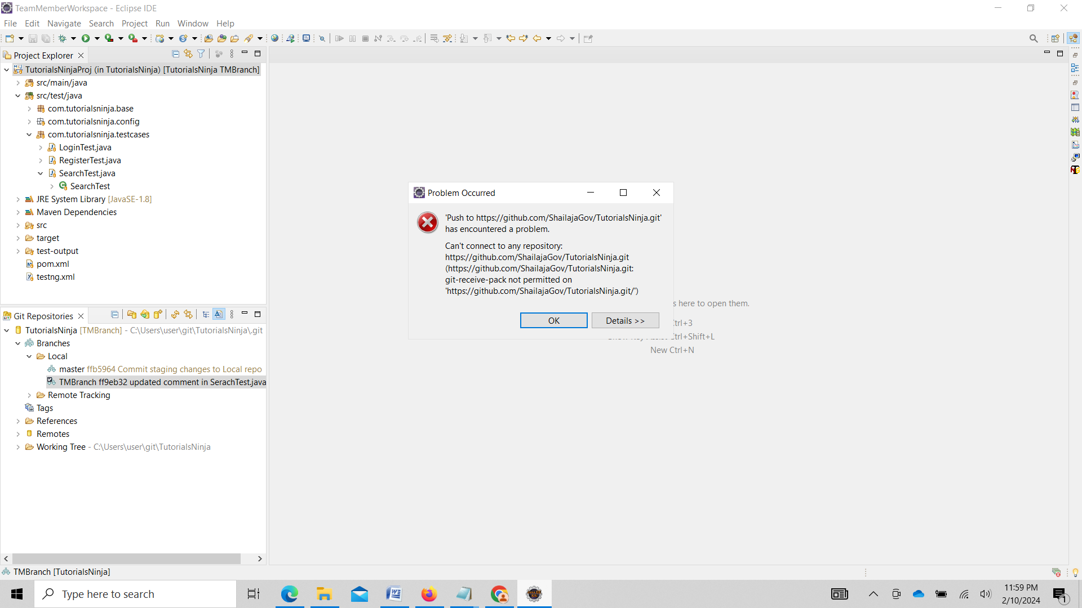

Sign into GitHub.com with lead credentials and Go to TutorialsNinja repository click Settings

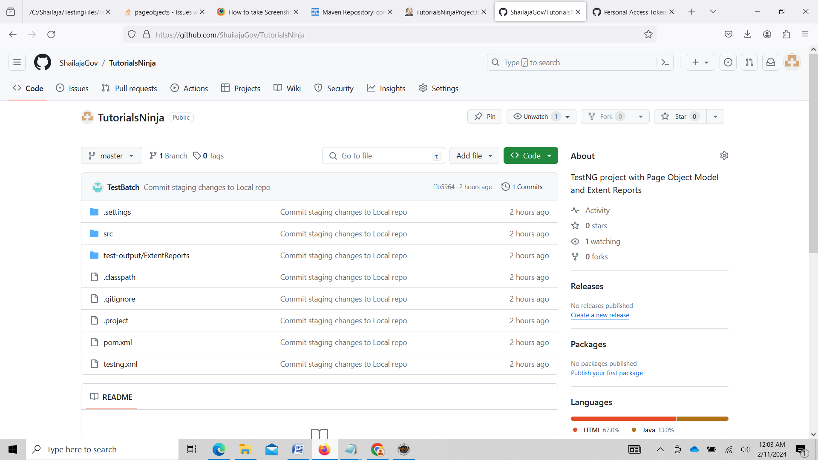

Click on Collaborators

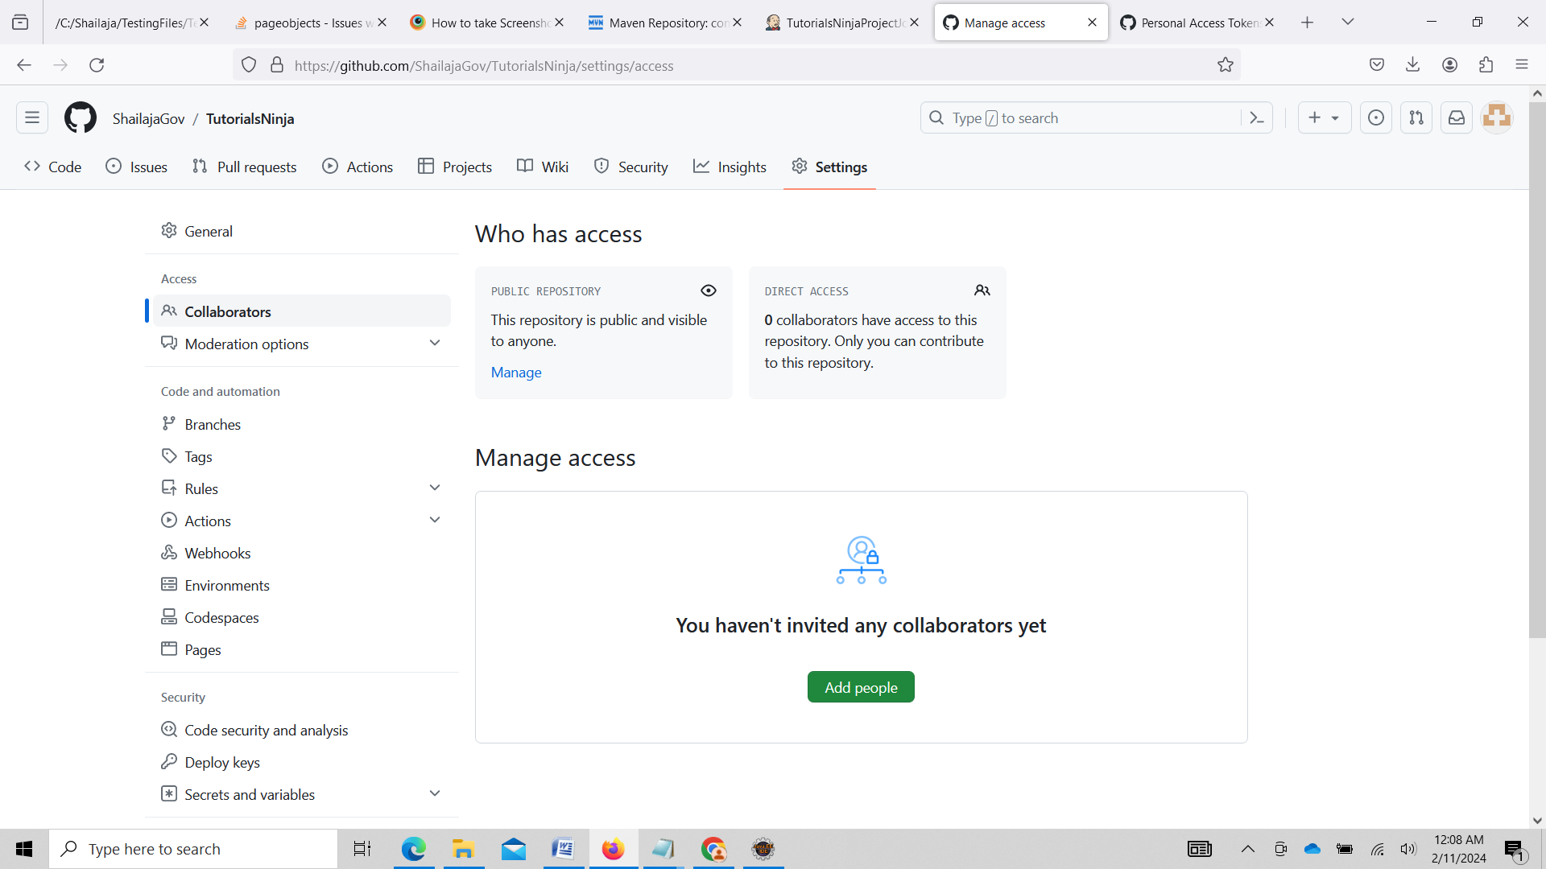

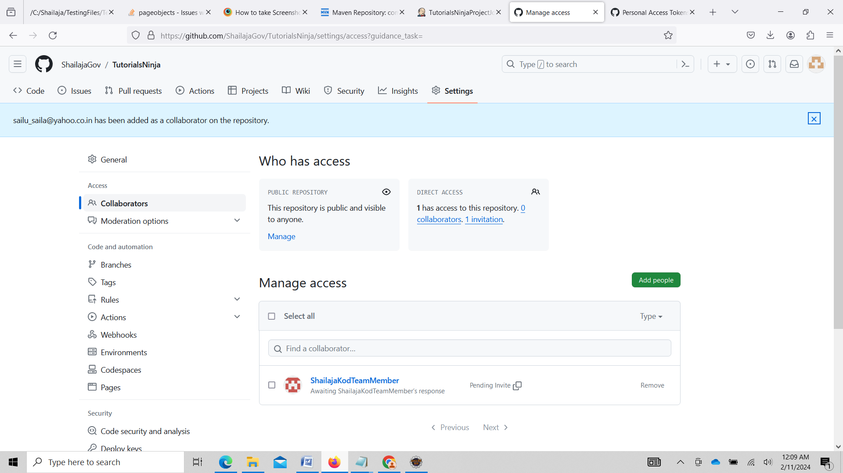

Check team member GitHub email [sailu_saila@yahoo.co.in](mailto:sailu_saila@yahoo.co.in)

Accept invitation

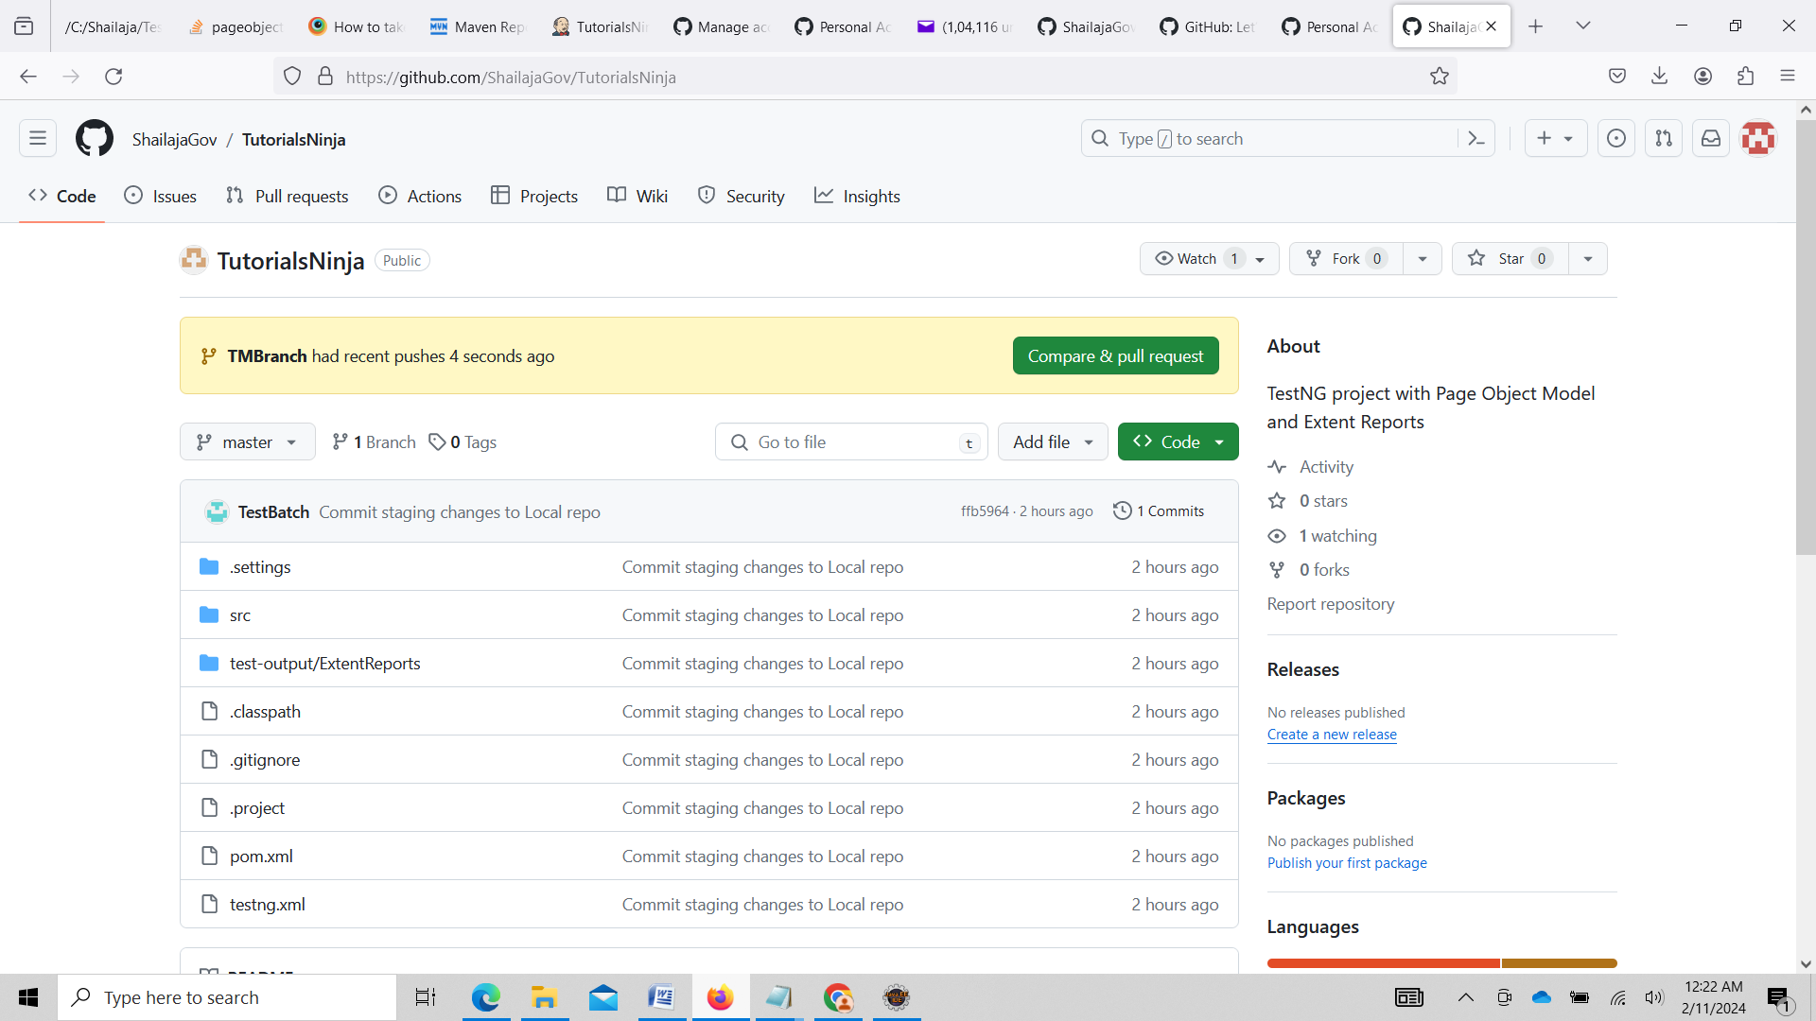

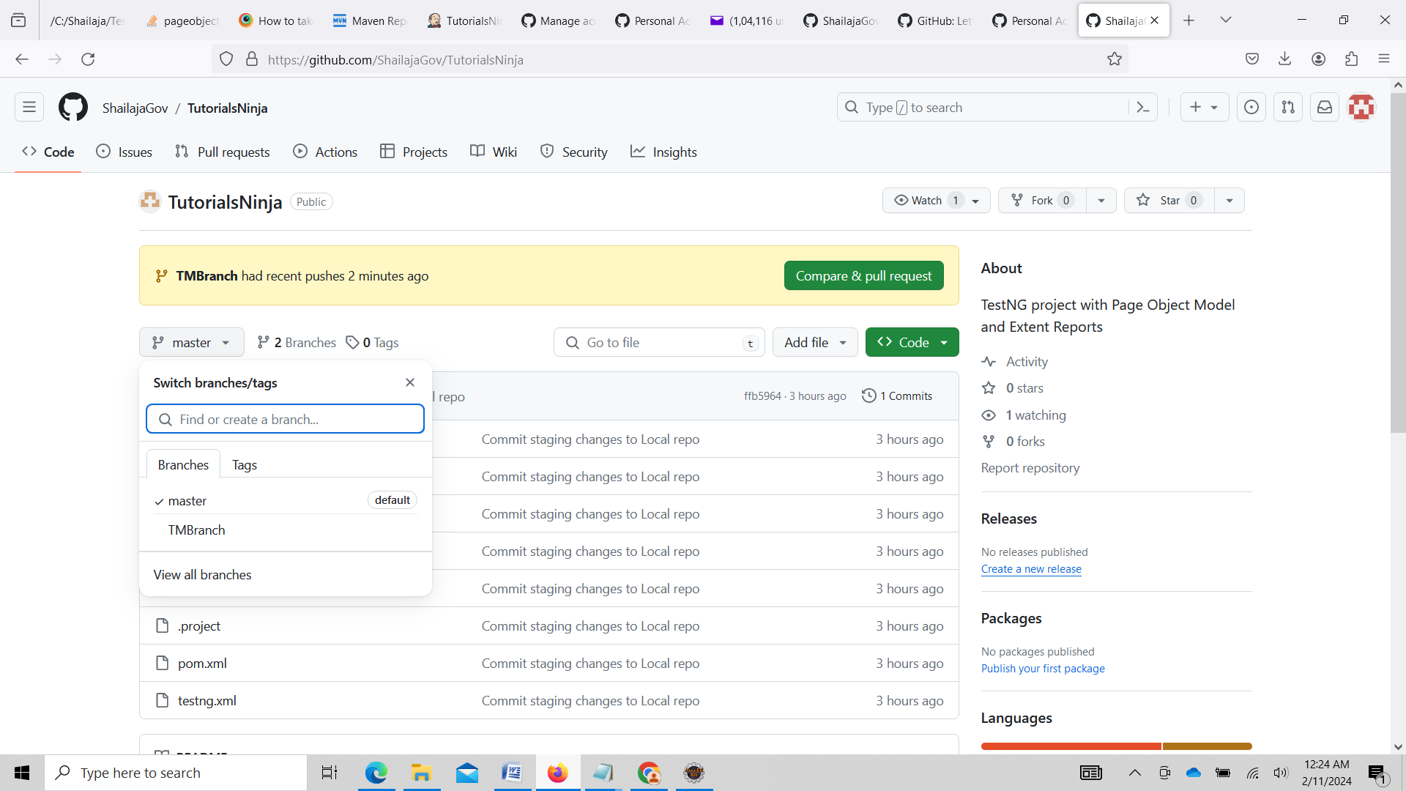

Click on Compare & Pull

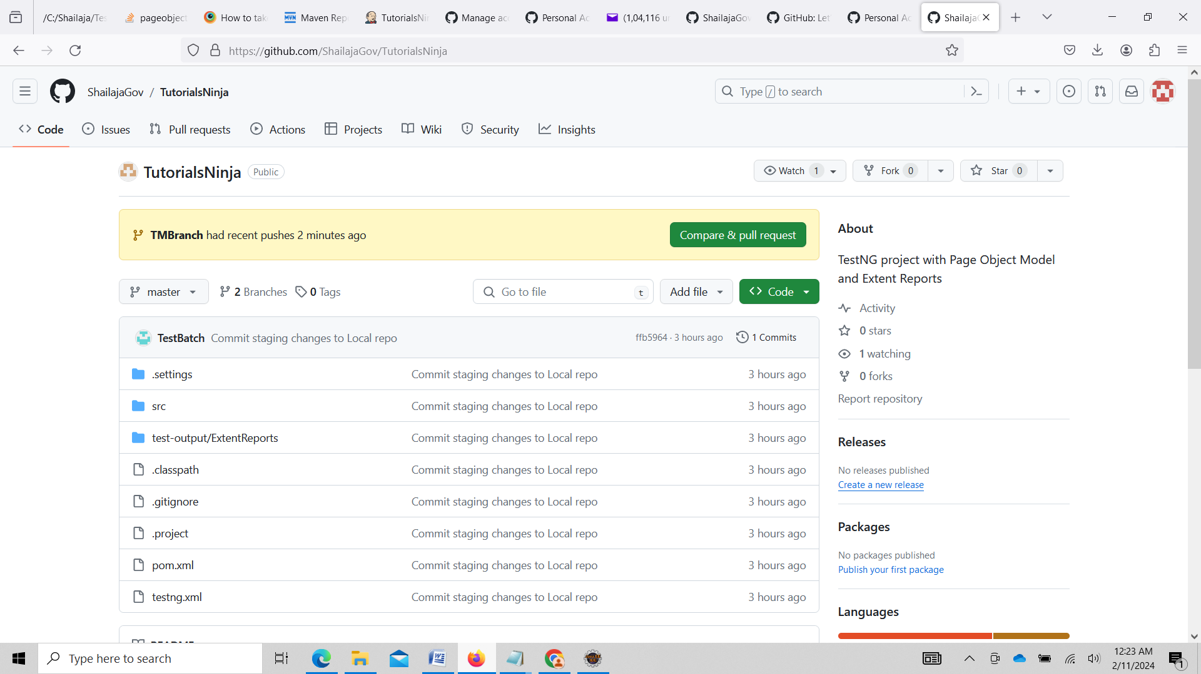

In the Next page enter comments select reviewer and Click create pull request

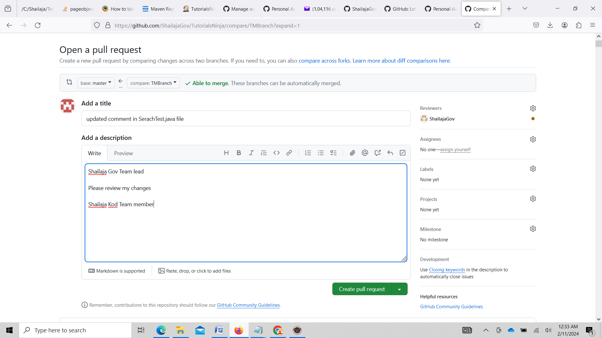

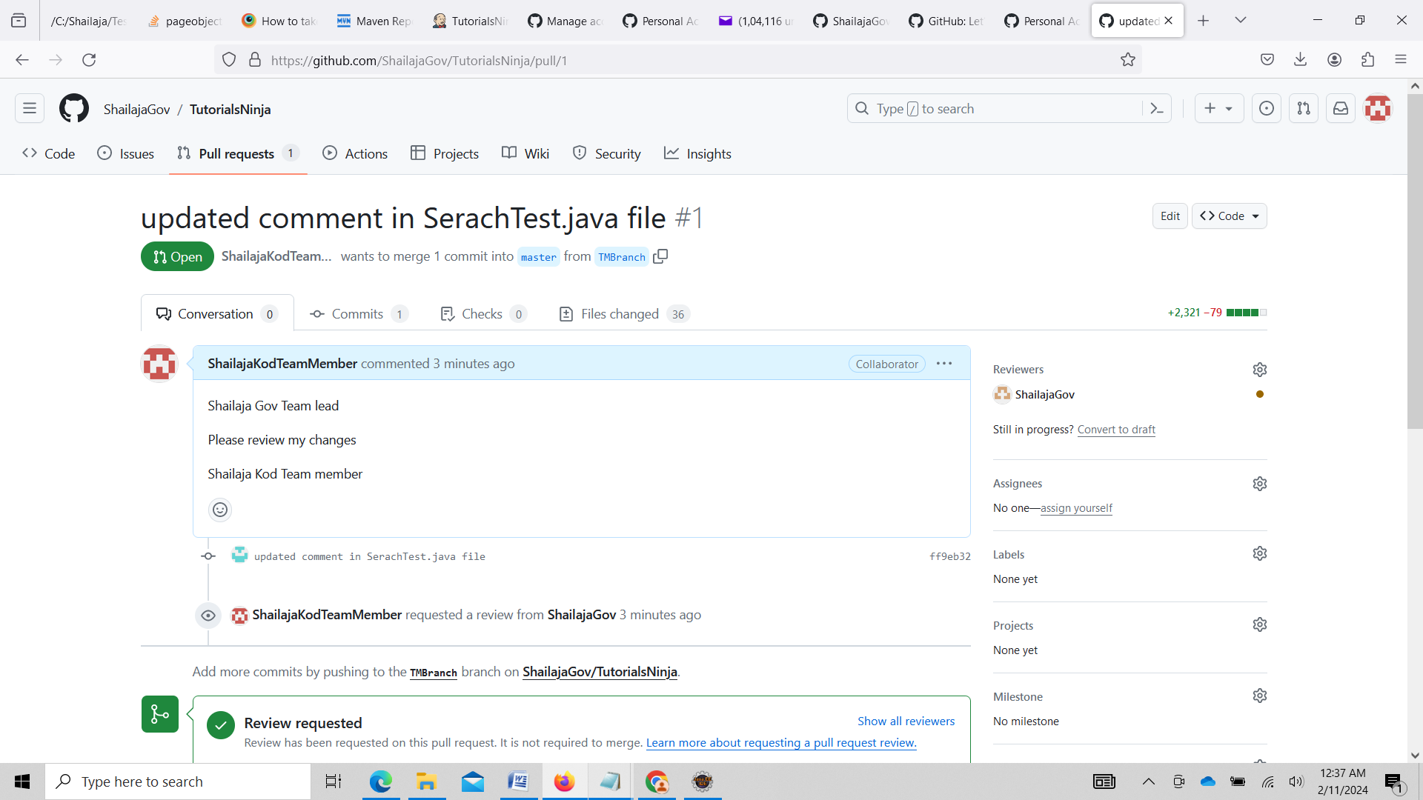

Login with Shailaja Gov [shailaja.sireesh@gmail.com](mailto:shailaja.sireesh@gmail.com)

Go to project repository click pull requests

Enter comment for team member saying it looks fine

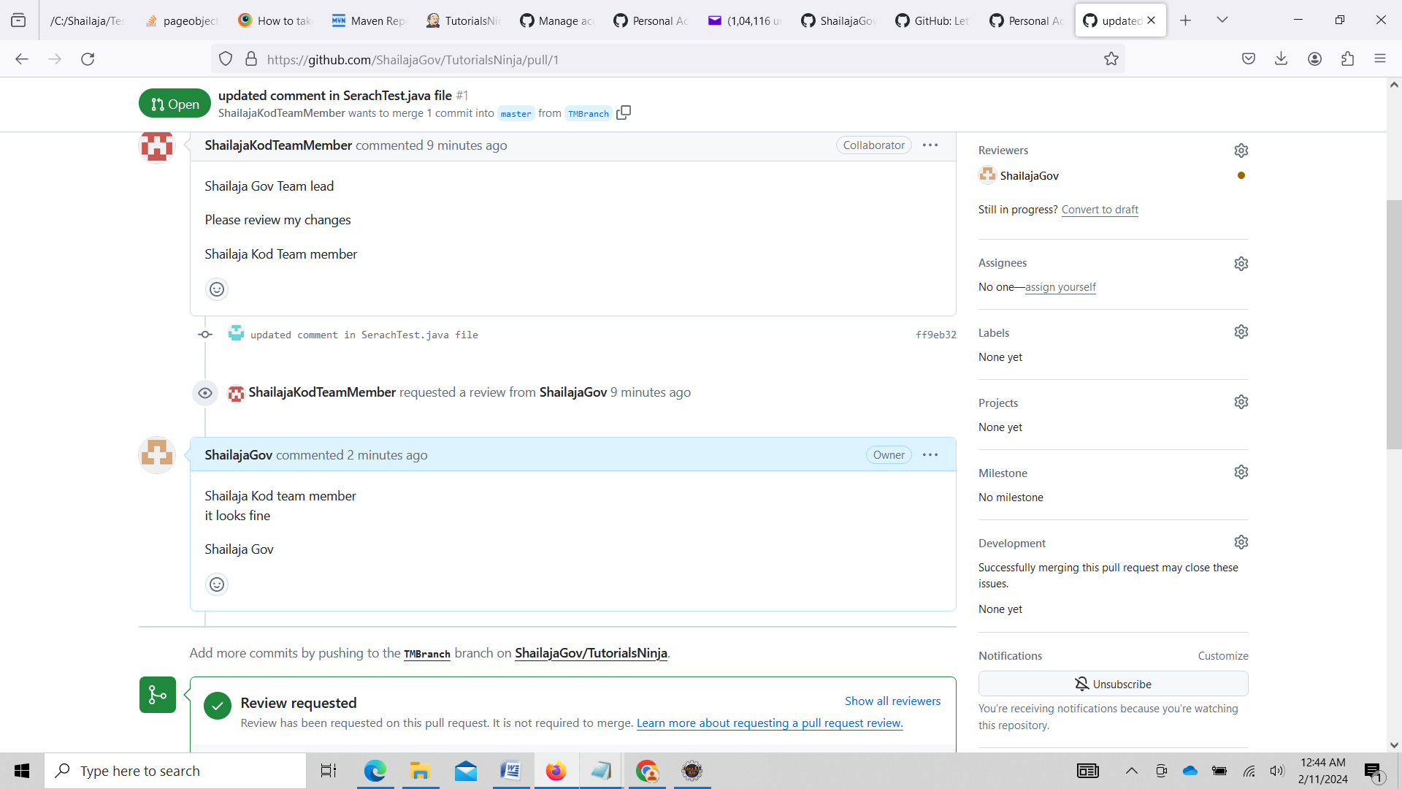

Merge to Master